

**SRS(Software Requirement Specification)**

**Course : CSE411**

**Section : 2**

**Semester : Fall2020**

**Course Title : Software Engineering and Information System Design**

**Project Topic**

**Universal Online Banking Management System**

**Submitted To:**

**Md. Mohsin Uddin**

Lecturer

Department of Computer Science & Engineering

East West University

**Submitted By**

**Md. Lutfullahil Labib (2017-1-60-015)**

**Shamimatul Jannat (2016-3-60-026)**

**Mst. Khadheza Sultana Erani (2017-2-60-098)**

**Submission Date: 06 January, 2021**

**Universal Online Banking Management System**

**Introduction:**

Universal or Global online banking is a web platform that combine all bank globally. User will able to transact money in same bank, other bank inside the country and outside the country. It will reduce user’s time and hassle of standing in a long line in bank to for transaction. Outside country it will convert the money based on the country.

Users can enjoy instant access from their computer or mobile device to a full range of services, allowing you to: Check balances on accounts and view records of your transactions. Pay bills automatically each month with easy-to-set-up auto payment. Transfer funds between accounts. Also between different banks and country. An online account is simple to open and easy to operate. It's convenient, because you can easily pay your bills and transfer your funds between accounts from nearly anywhere in the world.

You do not have to stand in a queue to pay off your bills or transfer money. Also you do not have to keep receipts of all of your bills, as you can now easily view your transactions.

It is available all the time. You can perform your tasks from anywhere and at any time, even at night or on holidays when the bank is closed. The only thing you need to have is an active internet connection.

It is fast and efficient. Funds get transferred from one account to the other very fast. You can also manage several accounts easily through internet banking. You can keep an eye on your transactions and account balance all the time.

You can get to know about any fraudulent activity or threat to your account before it can pose any severe damage.

Also the web app make easy to their user transfer money from one bank to another bank in the country or world easily by simple few steps. They also don’t need to worry about tax or transaction charge or change money values to country wise. All will work automatically.

In this Covid-19 pandemic situation, it is very risky to go to the bank for services. So people can easily access. This services are very effective at this time.

So, to make people easier, to give them happier and healthier life, we try to make an universal online banking management system web app where anyone can easily access by online and as well as offline too.

**Motivation:**

Our main objective is to be able to transfer money from any bank globally to another bank, not just transaction within the same banking institution.

It is aims to reduce the cost and hassle of transaction between most of or renowned bank globally.

Users won’t need to worry about Tax pay, money transaction between any bank in the country or world, debit, credit, money values change between countries etc. All possible things can do by this web app very easily and globally.

Admin or manager also can do their work by this web app and keep eye on every User and help them.

We want to make a well-organized banking management system which provides futuristic banking service towards the people of Bangladesh or any other country in the world.

This system can greatly reduce the risk of affecting from Corona virus.

We will try to maintain a good security system. One user can’t see other user information. So, it will be safe for the users.

**Challenges:**

Adding most of the bank globally.

In short duration the project need to be completed in PHP.

Have to handle all legal issues and privacy as different bank has different privacy system.

Need to add all kind of feature which all bank have.

Ensuring high security and protecting the client’s data.

Since this project is entirely team driven, we lack any client or upper-management feedback. Lacking well-defined client-requirements will make the development process a little more difficult.

Getting the team familiar with technologies they haven’t worked with before.

Making the design module more user friendly through non-functional requirements so that the customers can use it more smoothly.

Developing such a design which is always updating information, adding features.

A functional online management web app will have a large number of users. For the reason, we need large storage in our database system to secure all the information of our client. Our resource is limited. So, it isn’t possible for us to increase storage in our database system for our tight budget.

The technological system is updating day by day. For this reason, we can’t cope up with this technological update for our limited budget. If our budget is more, we can use the Big Data concept.

**Component Diagram**

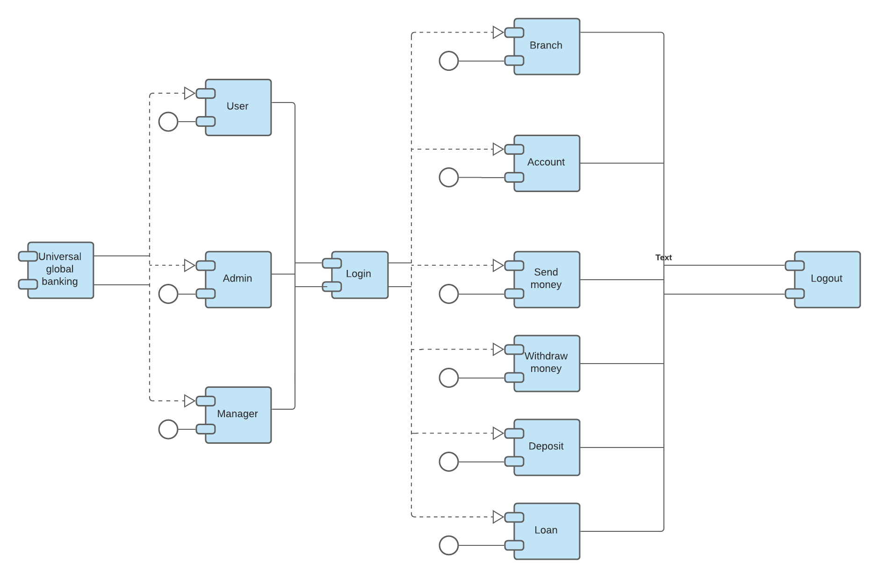

**Software Requirements:**

There are two types of requirements. They are **Non-functional requirements** and **Functional requirements**.

**Non-Functional Requirements:**

**Security Requirements:** Privacy is the most important thing for this web application. For protecting account user sensitive information and others things like password etc. will provide high security. One can’t see or access others account in the system so that the system should be used secure socket layer for all the transactions. We used **MD5 encryption method** to secure password.

**Account Requirements:** Will add a system for tax difficulties, as different country have different type of amount tax for transaction money.

**Efficiency Requirements:** Indexing will be added. Indexing will help to search. Through indexing searching will be easier, user will easily can find their desired bank account or information they want to do transaction in very short time.

If the system hasn’t fast searching capability, then user loses their interest on that system. It is a very important constraint of the system.

**Organizational Requirements:** In addition to our target audience, any bank account user in any age can easily work with that properly without facing any major difficulties. It will be well organized.

**Performance Requirements:** The system must be interactive and occurs less bugs on run time this system and this system is also very fast in each and every transactions.

**Maintainability/ Development Requirements:** This system should have maintainability power. If this system hasn’t maintain capability and the system will have any bug or crash then it won’t be fix and the system totally failed to do it works. Also for future, more functional requirements can be added and system can be developed easily without changing the whole software.

**User friendly:** The system must be user friendly. User will not give interest if the system is not friendly. The system should be very handy so that the user can easily use it. We make simple but nice User Interface, hover-actions by using HTML, CSS & JS. We also make the web-app **responsive** for user-friendly for any device.

**Each input, option, negative value and possible all error or garbage/fault input is handled. And used Session for every possible step.**

The goal is to ensure readily available services to user for transaction and withdrawing money.

**Functional Requirements:**

**User authentication:** Since our web-app deal with sensitive information about the user’s information, a thorough authentication procedure should be followed.

**Scenario:** When a user/manager/admin/super-admin tries to access their account or use URL while they are not logged in, they would be redirected to the login page. Once the user enters their username and password and authentication is complete, they will be redirected to their desired page. Pages with sensitive/personal information can only be accessed through logging in to the system.

***Pages -***

**#Home:** Homepage will contain the option’s Login for user and bank’s admin/manager, Register for new bank or new user and also shows the contact us and about us page’s buttons & options.

**URL**: [Universal Bank - Login](http://localhost/UniversalBank/) = [Universal Bank - Login](http://localhost/UniversalBank/index.php) = http://localhost/UniversalBank/ = http://localhost/UniversalBank/index.php

**#Contact:** In contact us there will phone number and email for any kind of query related bank. (Social media’s account will be also included.)

**#About Us:** In about us, there will description about our services and others procedure about bank. (Social media’s account will be also included.)

**There will be 3 types of users for login,**

**1. Super Admin, 2. Bank Admin/Manager, 3. User.**

**#1. Super Admin Login:** Administrators of the system or web app. It will control our whole system, super admin will approve new bank’s registration, when someone will registered for new bank it will directly not be approved, it will be approved by super admin. When super admin will review and approved it a confirmation email will be send to manager. Admin will approve the bank’s account. But admin can’t see or do anything he/she want with user or bank’s account. There will be security.

For login as Super Admin he/she have to use especial URL.

**URL**: [Universal Bank - Super Admin](http://localhost/UniversalBank/admin-panel/login.php) = <http://localhost/UniversalBank/admin-panel/login.php>

**Input:** username**,** password (password has eye button or option to change by clicking once on/off to password or text mode/view)**.  
Output**: Active User list, Active Banks List, Pending Bank Approvals, All Transactions & Change Password. (In Nav-bar-- Navigation Bar will always show Admin & Logout button until logged out).

**## Active User list:** Here will show all active user list & their only necessary info including picture and current balance.

**## Active Banks List:** Here will show all active bank list & their only necessary info. Also have button to deactivate the banks.

**## Pending Bank Approvals:** Here will show all inactive or pending bank list & their only necessary info. Also have button to activate the banks.

**## All Transactions:** Here will show All Transactions of all Bank's all Users. (Withdraw, Deposit and Transfer).

**## Change Password:** Here super-admin can change password. But have to match old password, new password can’t be old password, confirm password must match new password and new Password must contain *At least 8 characters *At least a number *At least a letter * At least one Capital letter. (Password has eye button or option to change by clicking once on/off to password or text mode/view).

**#2. Bank Admin/Manager Login:** Admin/Manager of each bank. By entering email and password & choosing bank admin/manager can login. Each bank have separate admin/manager.

**Input:** choose bank, username, password (password has eye button or option to change by clicking once on/off to password or text mode/view).

**Output**: Active Users List, Pending User Approvals, Bank Summary, Transaction History & Change Password. (In Nav-bar-- Navigation Bar will always show Bank’s Name-home page of bank or bank page & Logout button until logged out, also home, contact & about us page-button).

**## Active Users List:** Here will show all active user list of that bank & their only necessary info including picture and current balance. Also have button to deactivate the users.

**## Pending User Approvals:** Here will show all inactive or pending user list of that bank & their only necessary info including picture and current balance. Also have button to activate the users.

**## Bank Summary:** Here will show the bank’s only necessary info including bank’s status (Active or Inactive) and whole bank’s current balance.

**## Transaction History:** Here will show All Transactions of that Bank's all users. (Withdraw, Deposit and Transfer).

**## Change Password:** Here admin/manager can change password. But have to match old password, new password can’t be old password, confirm password must match new password and new Password must contain *At least 8 characters *At least a number *At least a letter * At least one Capital letter. (Password has eye button or option to change by clicking once on/off to password or text mode/view).

**#3. User Login:** User of any bank. By entering email and password & choosing bank any user can login.

**Input:** choose bank, username, password (password has eye button or option to change by clicking once on/off to password or text mode/view).

**Output:** Personal Information, Account Summary, Change Password, Make A Transaction & Transaction History. (In Nav-bar-- Navigation Bar will always show User’s Name-home page of user or profile page & Logout button until logged out, also home, contact & about us page-button).

**## Personal Information:** Here will show only user’s necessary personal info including picture. Also have button to deactivate the users.

**## Account Summary:** Here will show user’s account number, account status (active/inactive) & current balance.

**## Change Password:** Here user can change password. But have to match old password, new password can’t be old password, confirm password must match new password and new Password must contain *At least 8 characters *At least a number *At least a letter * At least one Capital letter. (Password has eye button or option to change by clicking once on/off to password or text mode/view).

**## Make A Transaction:** (If active user.) Deposit Money, Withdraw Money & Transfer Money buttons.

(If Inactive User), then will show “Wait till your account is activated to Start making Transactions”.

1. **Deposit Money:** Here User have to fill up form Username/Email, Password (Password has eye button or option to change by clicking once on/off to password or text mode/view), Amount of money (can’t be negative value) & 4 digit secret pin (“1234” by default).
2. **Withdraw Money:** Here User have to fill up form Username/Email, Password (Password has eye button or option to change by clicking once on/off to password or text mode/view), Amount of money (can’t be negative value & can’t more than balance) & 4 digit secret pin (“1234” by default).
3. **Transfer Money:** Here User have to fill up form Username/Email, Password (Password has eye button or option to change by clicking once on/off to password or text mode/view), Amount of money (can’t be negative value & can’t more than balance), Target Account number (of any user), Target Bank (of that user’s bank name) & 4 digit secret pin (“1234” by default).

**## Transaction History:** Here will show All Transactions of that users. (Withdraw, Deposit and Transfer).

**Registration: There will be 2 types of Registration.** As user & for New bank request.

**#User Registration:** User need to do registration. Registration will contain user’s NID number, first name, last name, phone number, gender, email, password, confirm password, address, bank name/choose option, user’s photo by uploading jpg/jpeg/png file & account number (by producing random value). [Password must contain *At least 8 characters *At least a number *At least a letter * At least one Capital letter.].

After the registration a request will be send to manager to active that user’s account, when manager will approve the request, user can do all transactions. Until then, user only can login and see his/her status but can’t make any transactions.

**(Users Uploaded file of photo will automatic move into main pc or data center image folder)**

**#New Bank Registration:** Here, a person need to do registration. Registration will contain Bank Name, phone number, authorization ID, address, email for user and bank-email for login (@ubbl.com) & password, confirm password. [Password must contain *At least 8 characters *At least a number *At least a letter * At least one Capital letter.].

After the registration a request will be send to Super Admin of web app to active that bank’s account, when Super Admin will approve the request, admin of that bank can do login & rest works. Until then, bank can’t login and user can’t register account to that bank.

**#Log-Out:** when the button logout will press, the logout page will show for 2 seconds and will bring to Home page.

**Other: After every successful or unsuccessful process or for error every necessary notification will show below.**

**Technological Specs:**

Front-End: HTML, CSS, Bootstrap & JS.

Back-End: PHP (Raw code).

Database: MySQL (xampp).

**UML Use-case Diagrams**

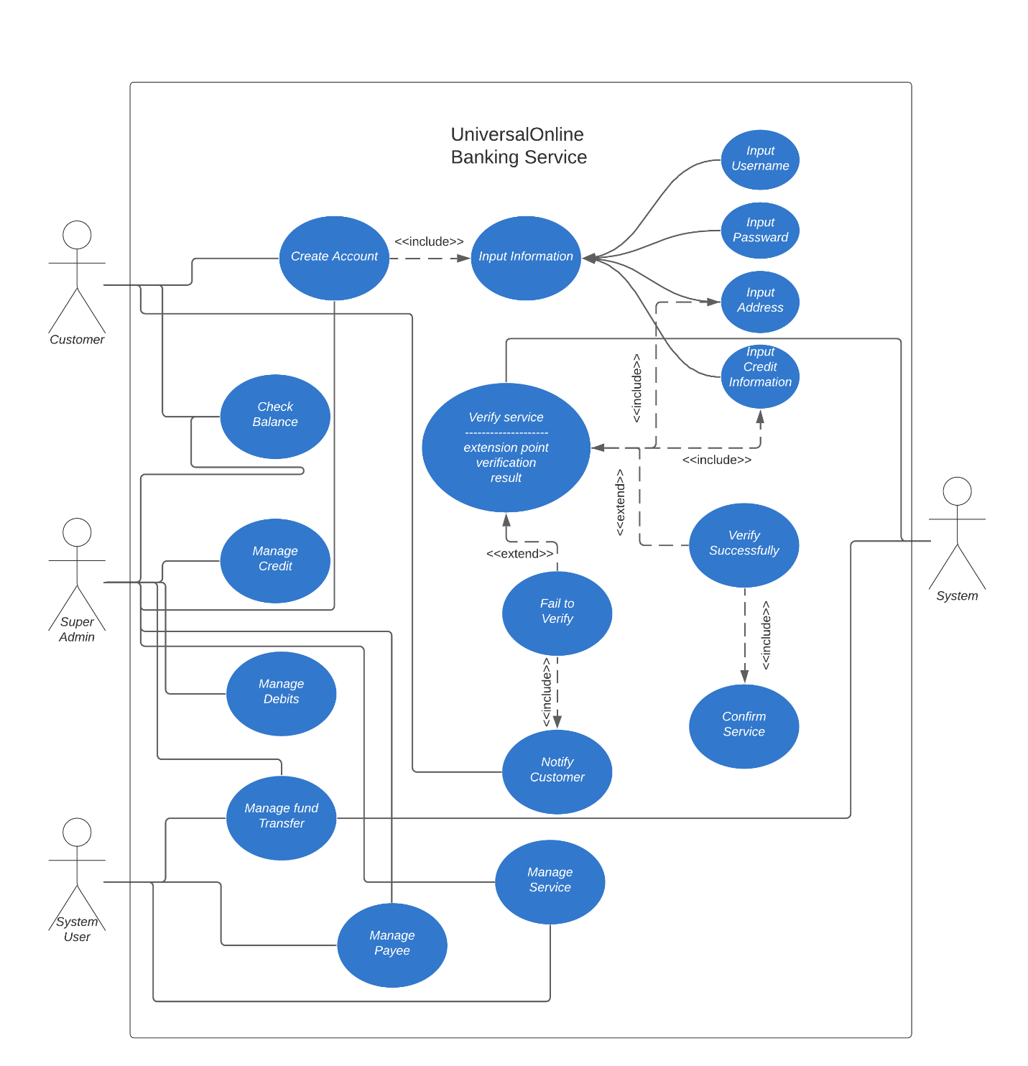

**UML Class Diagram**

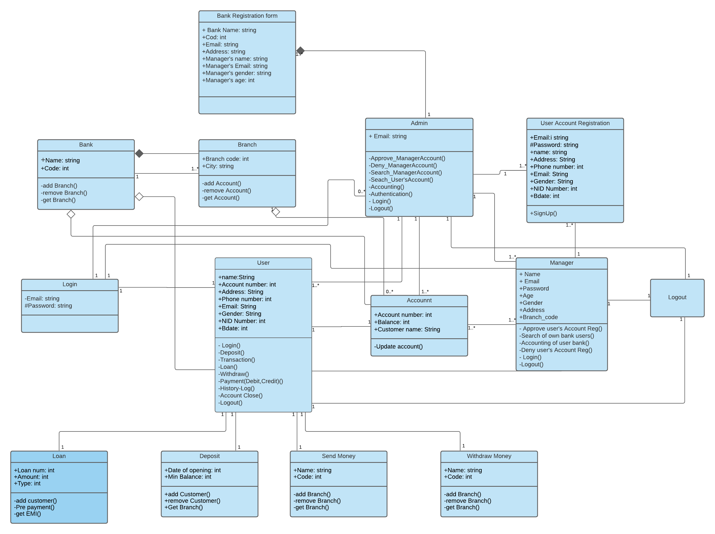

**UML Activity Diagram**

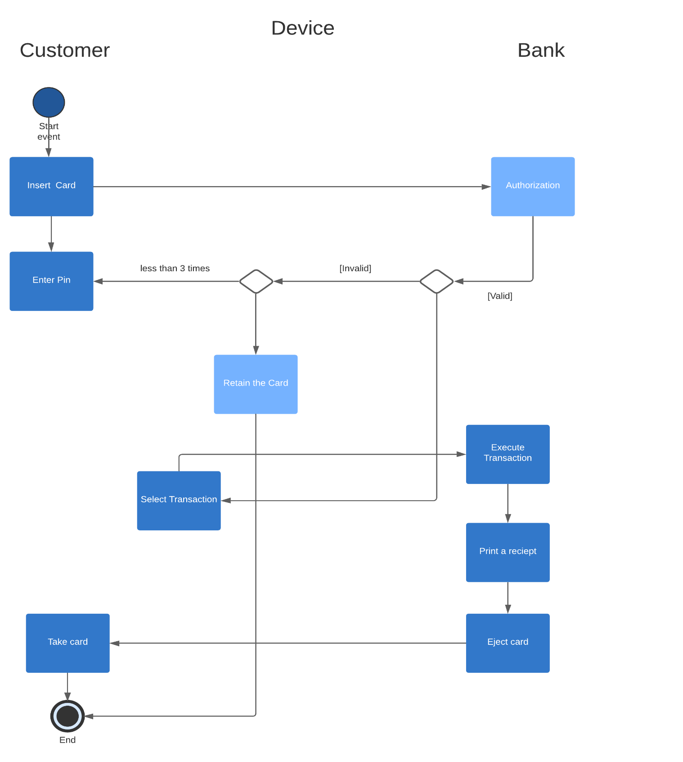

**UML Sequence Diagram**

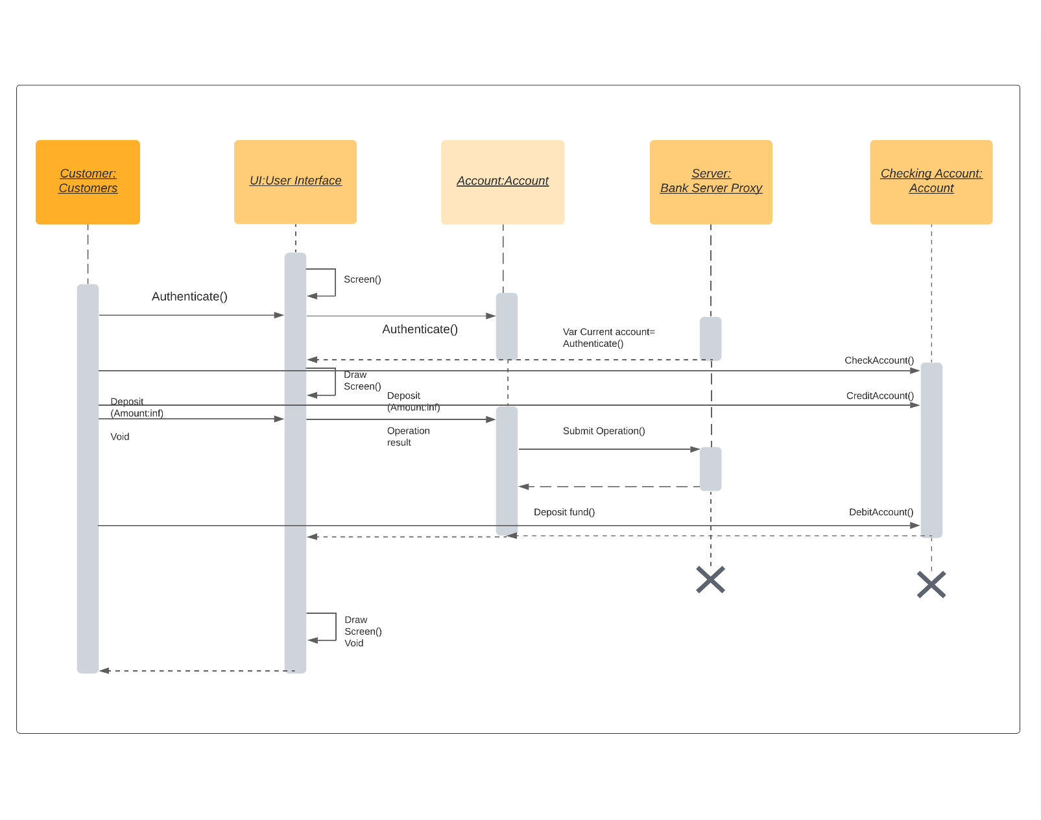

**Entity Relationship Diagram**

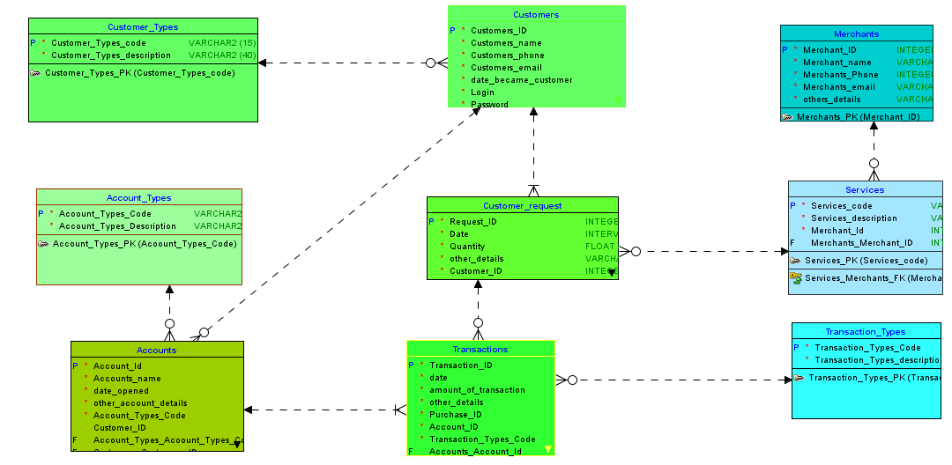

**User Interface Screenshots**

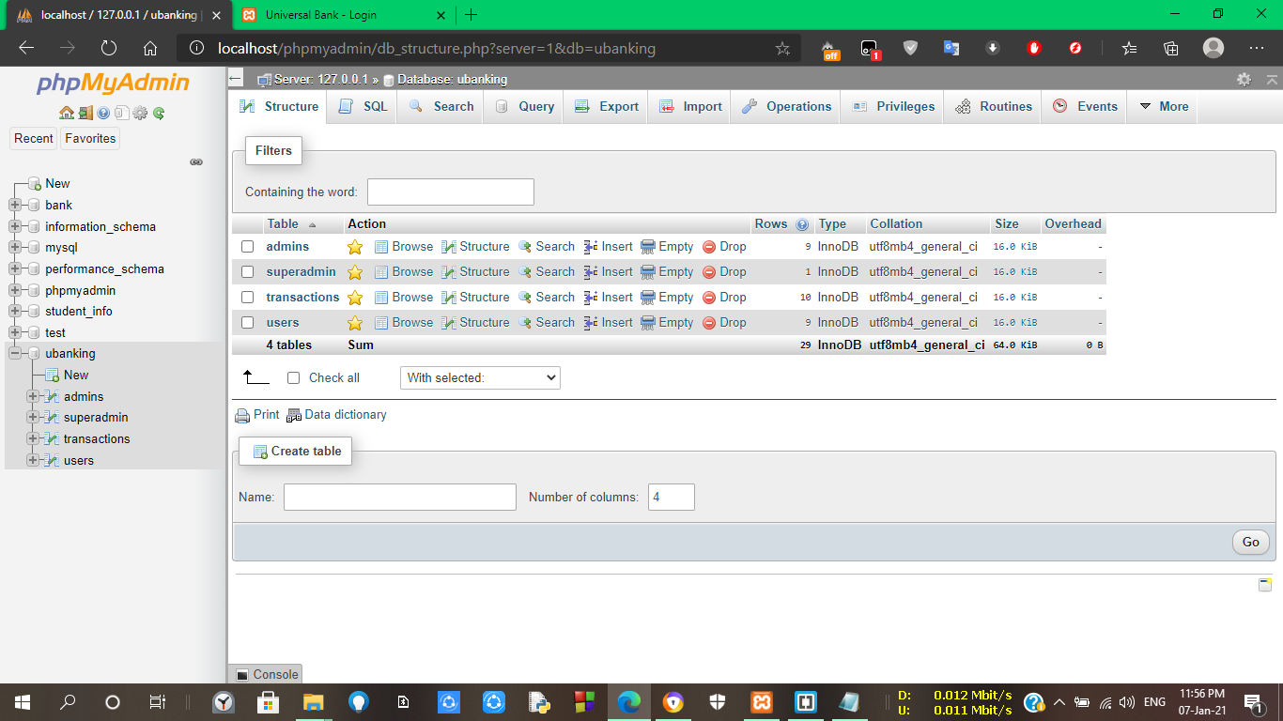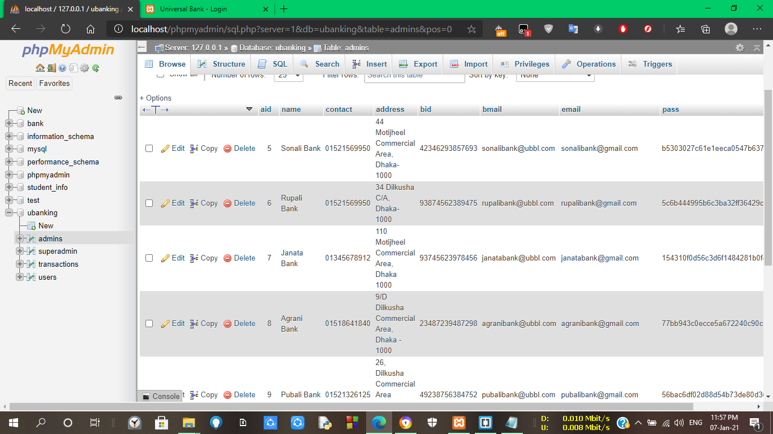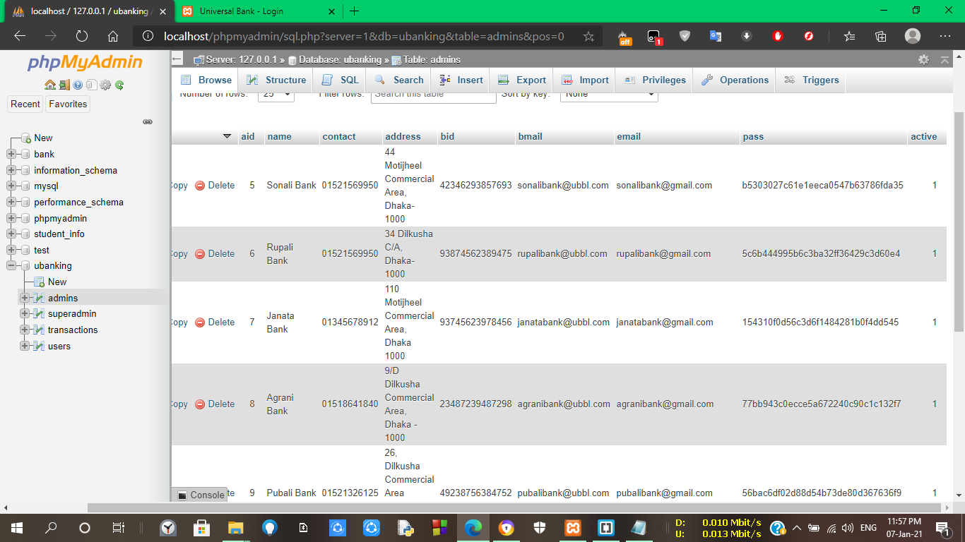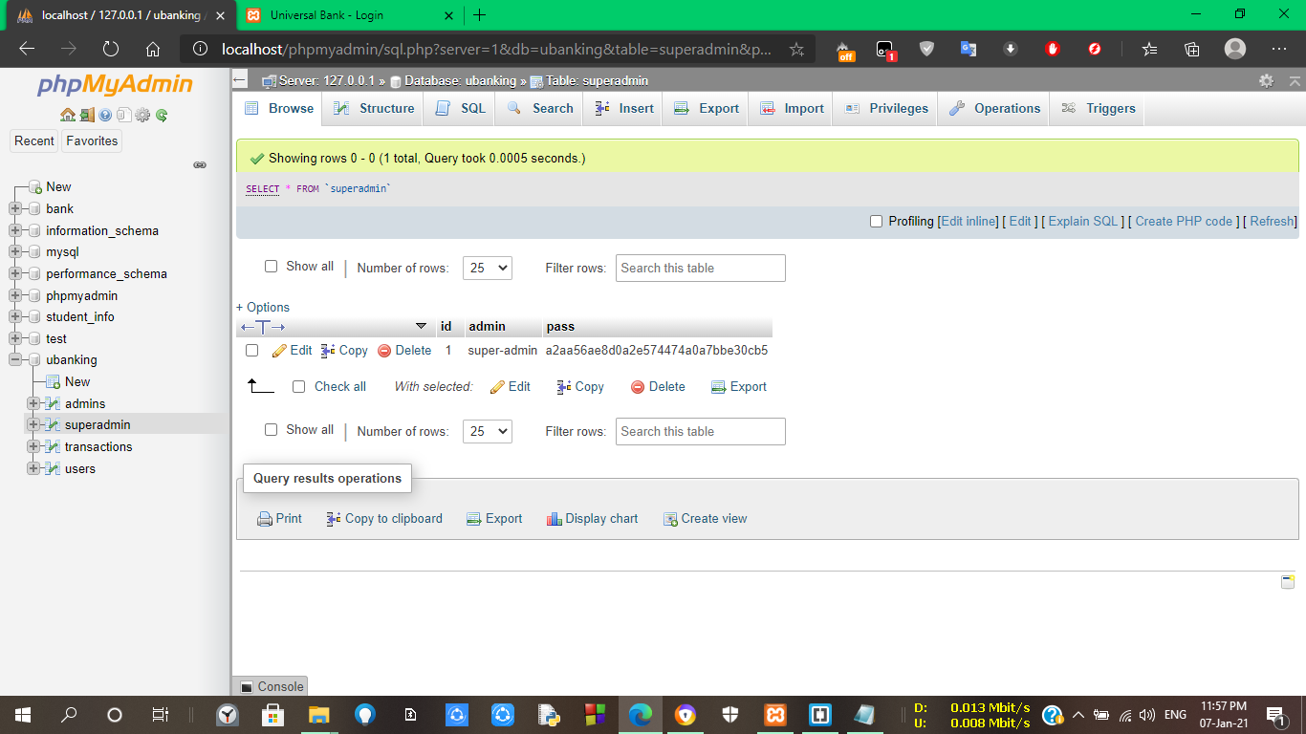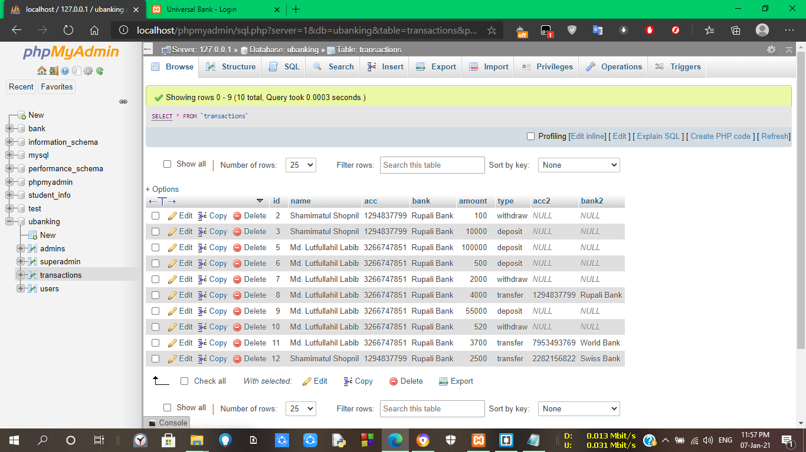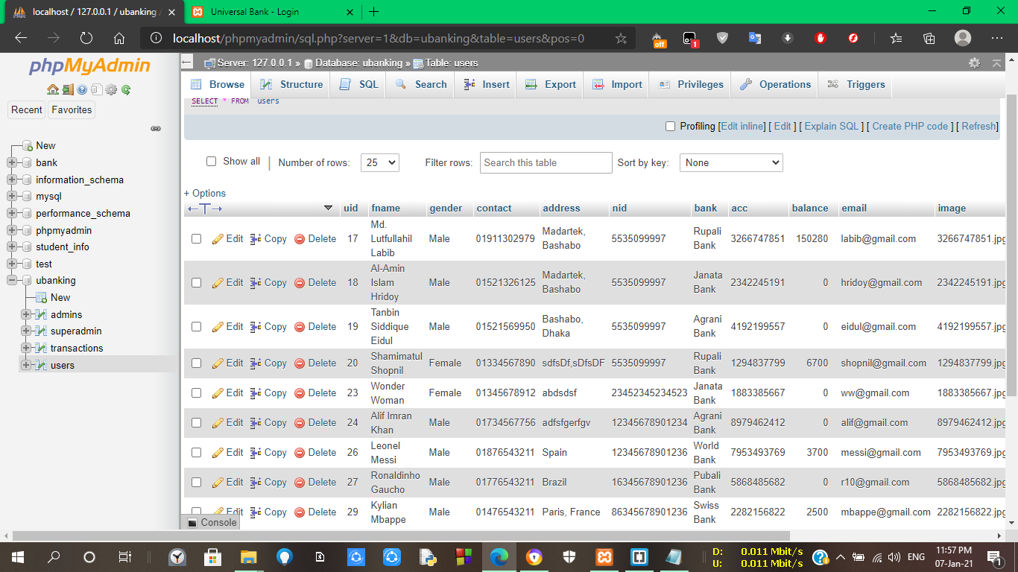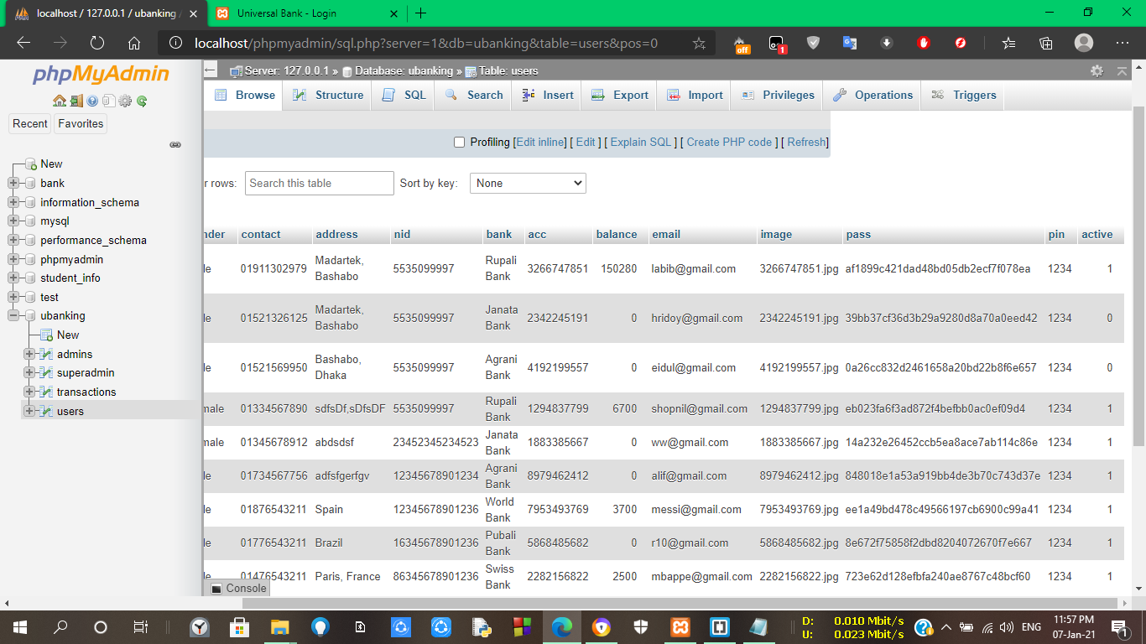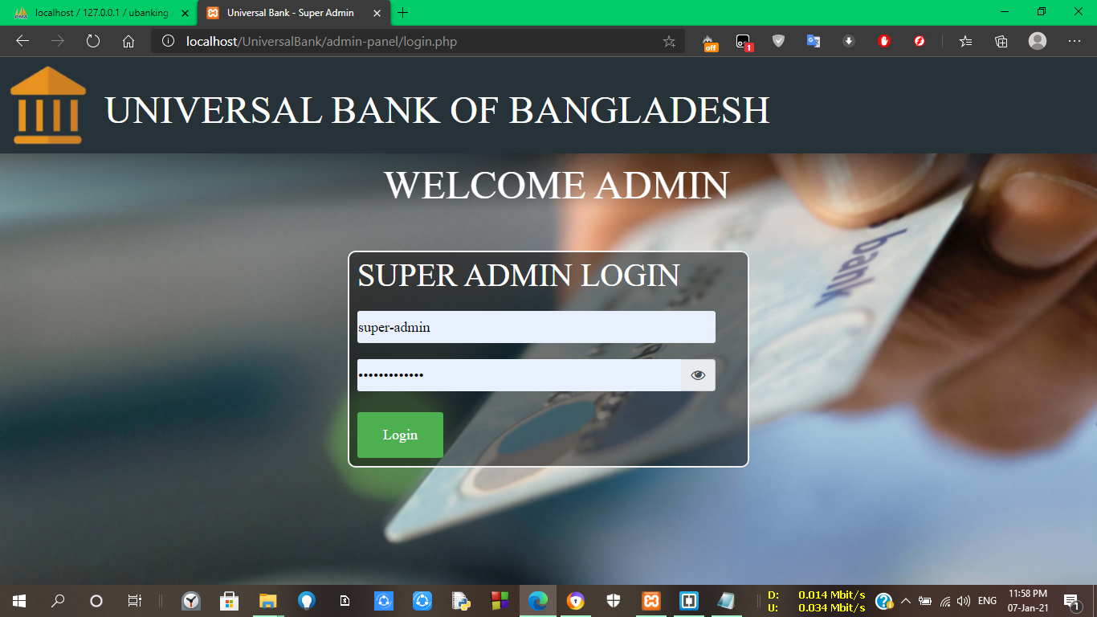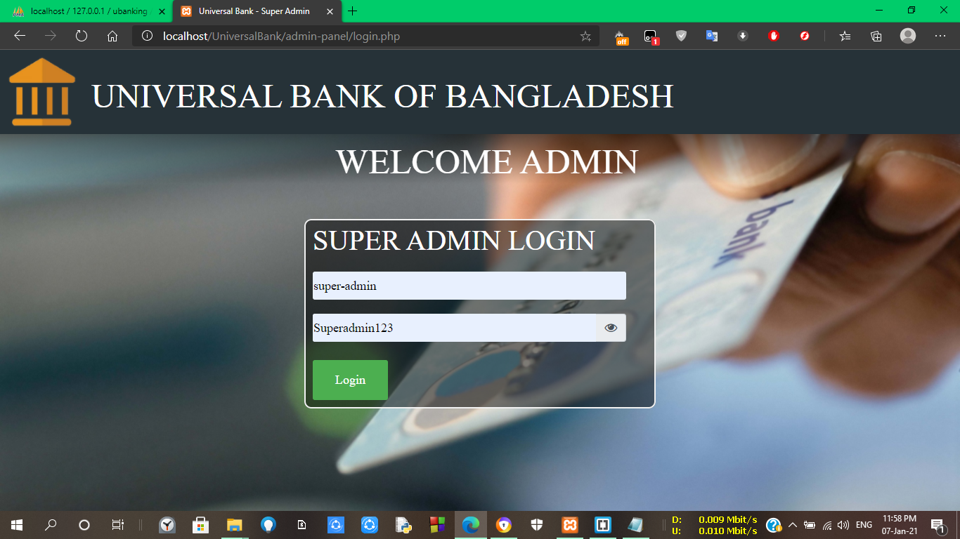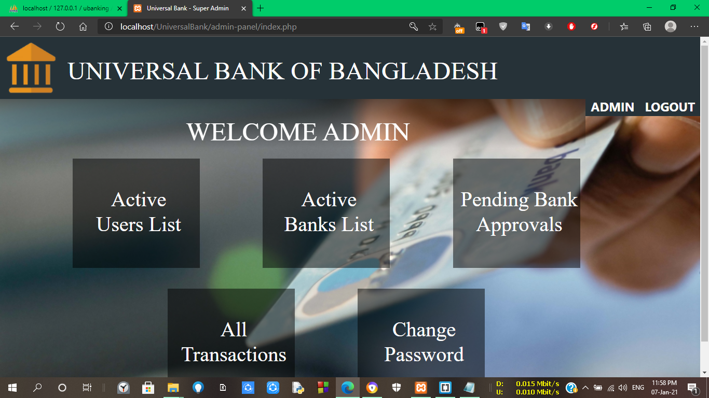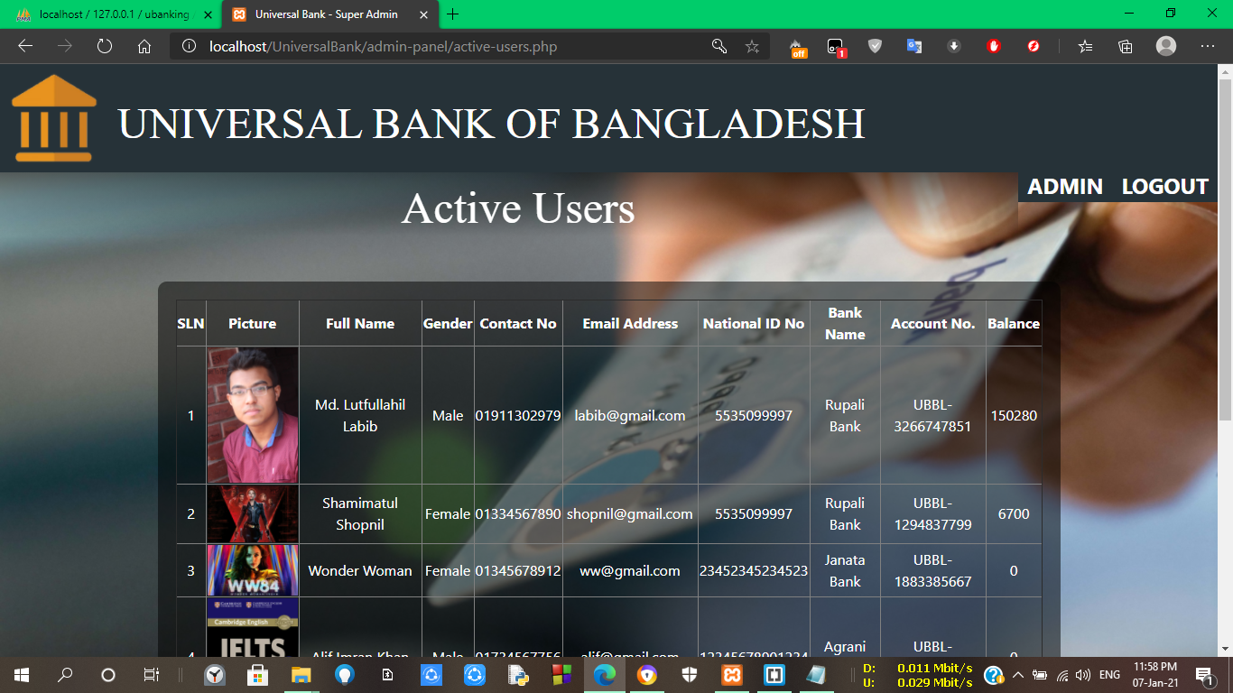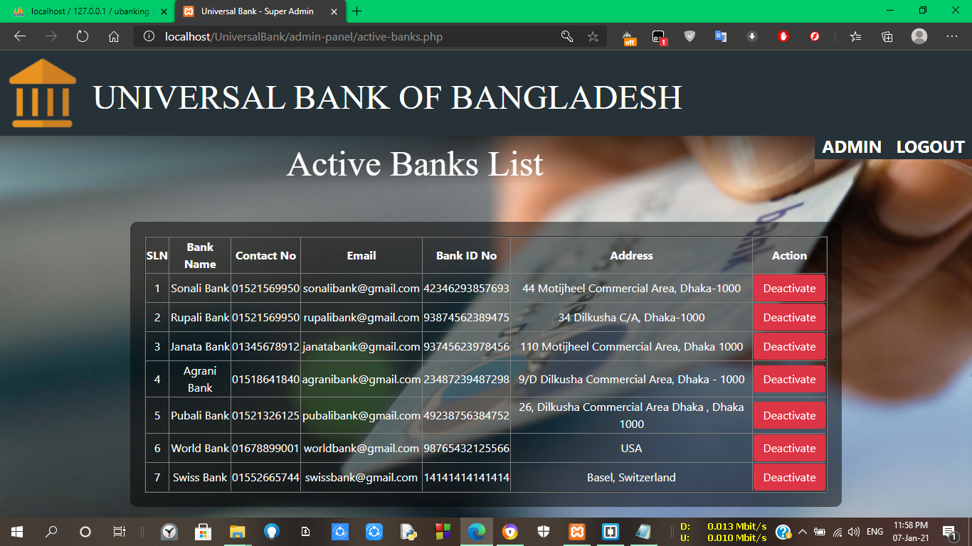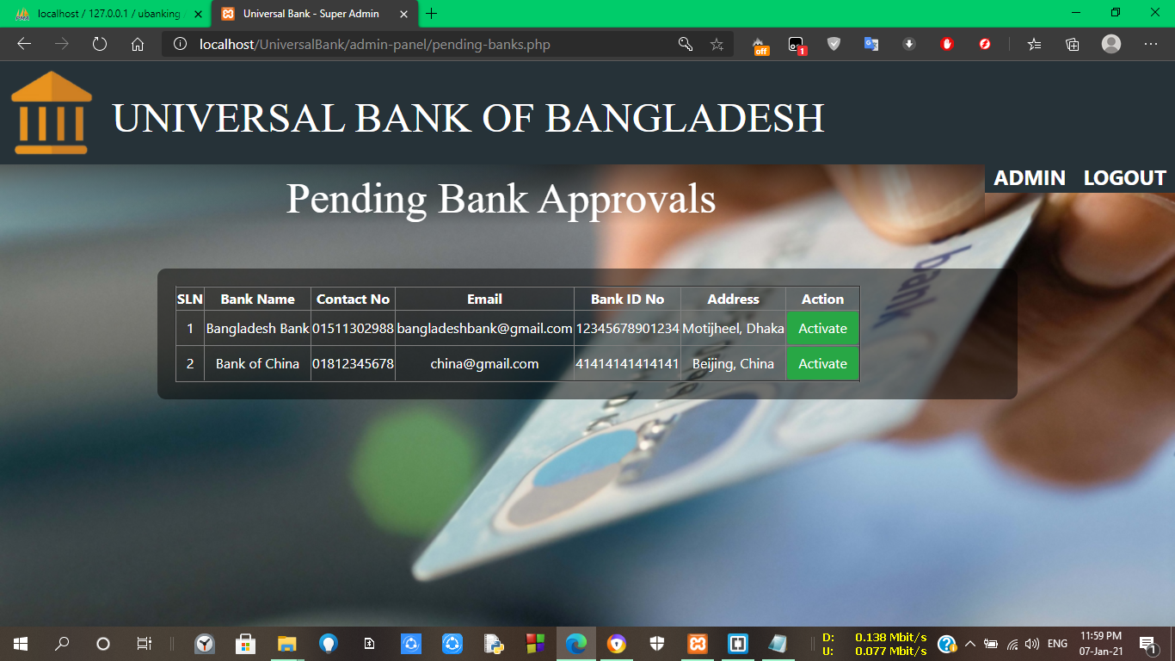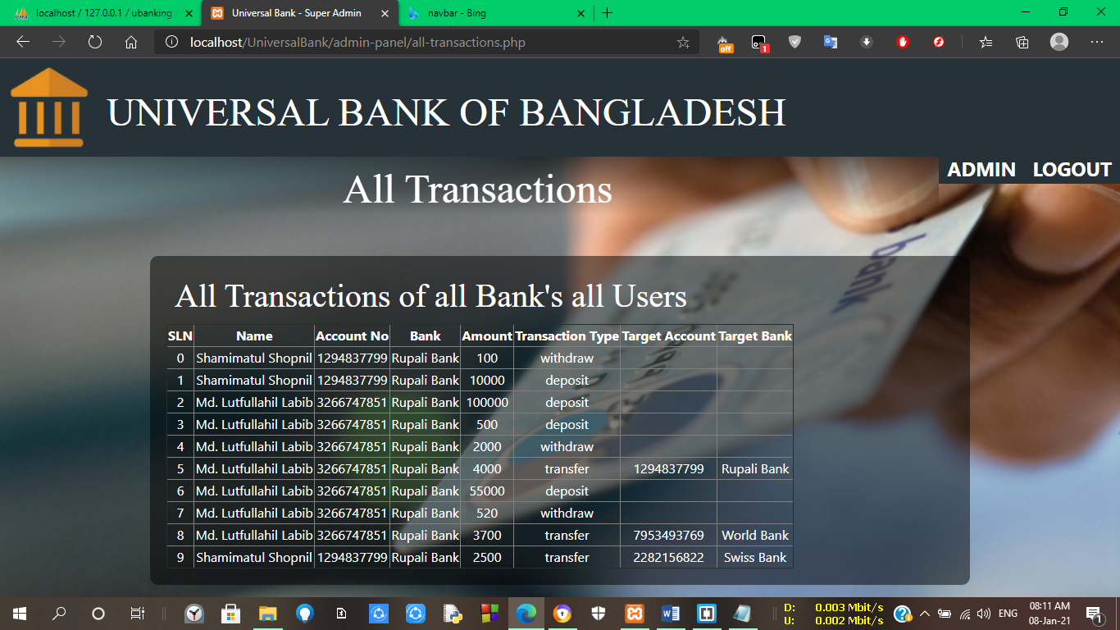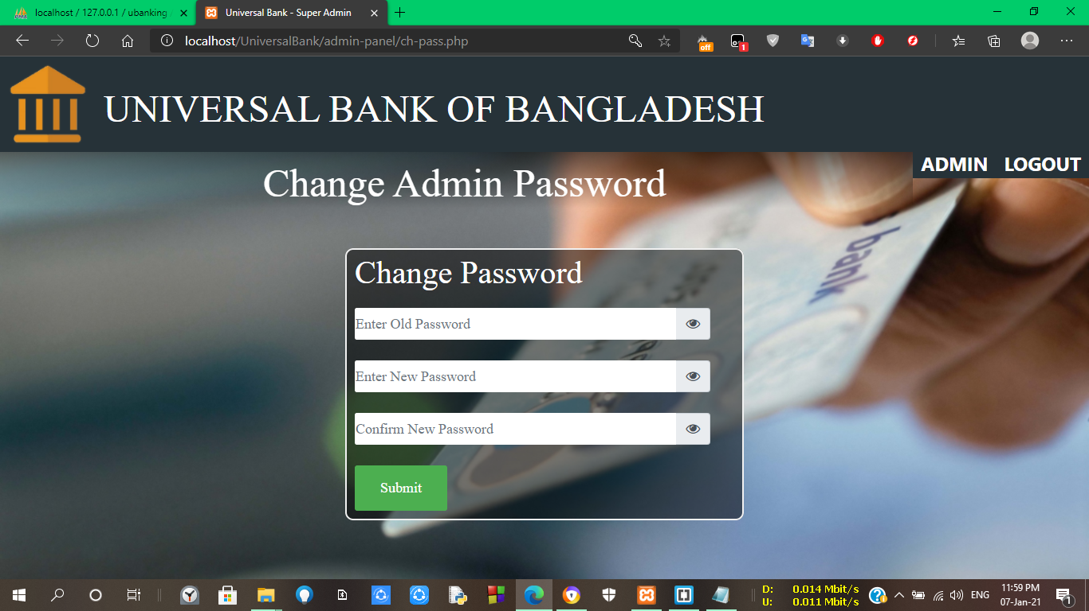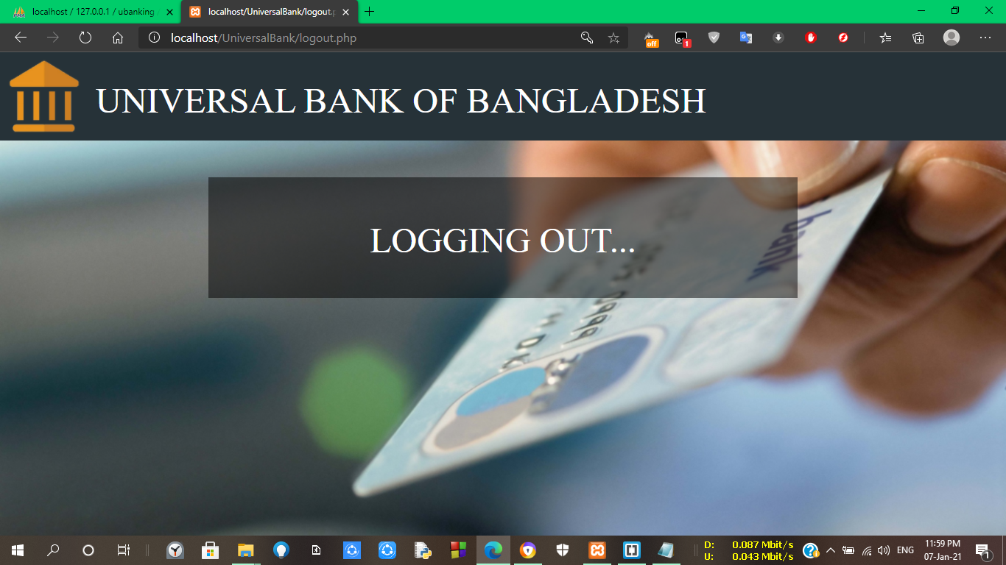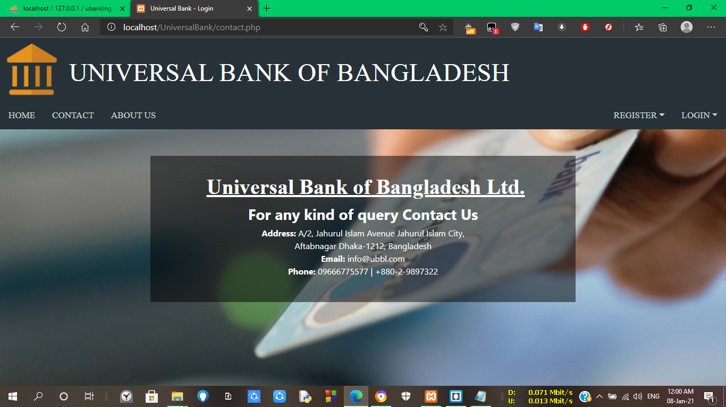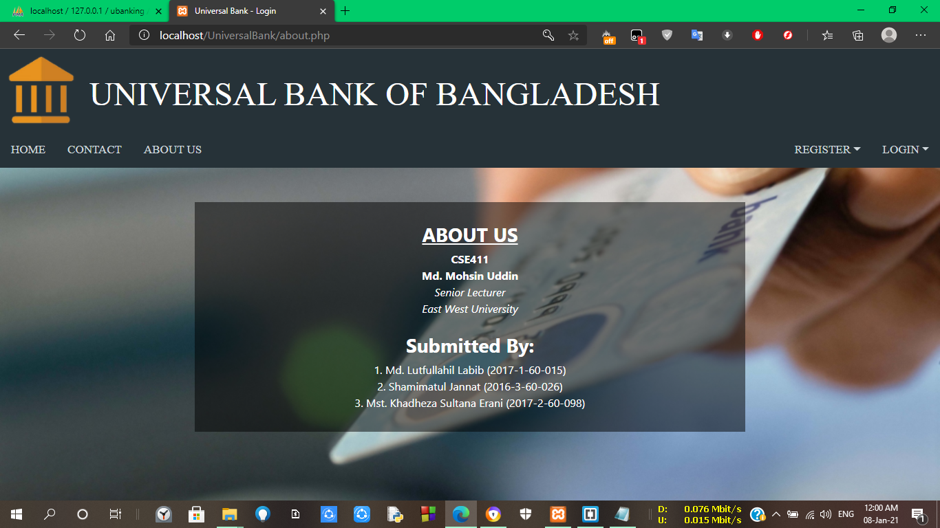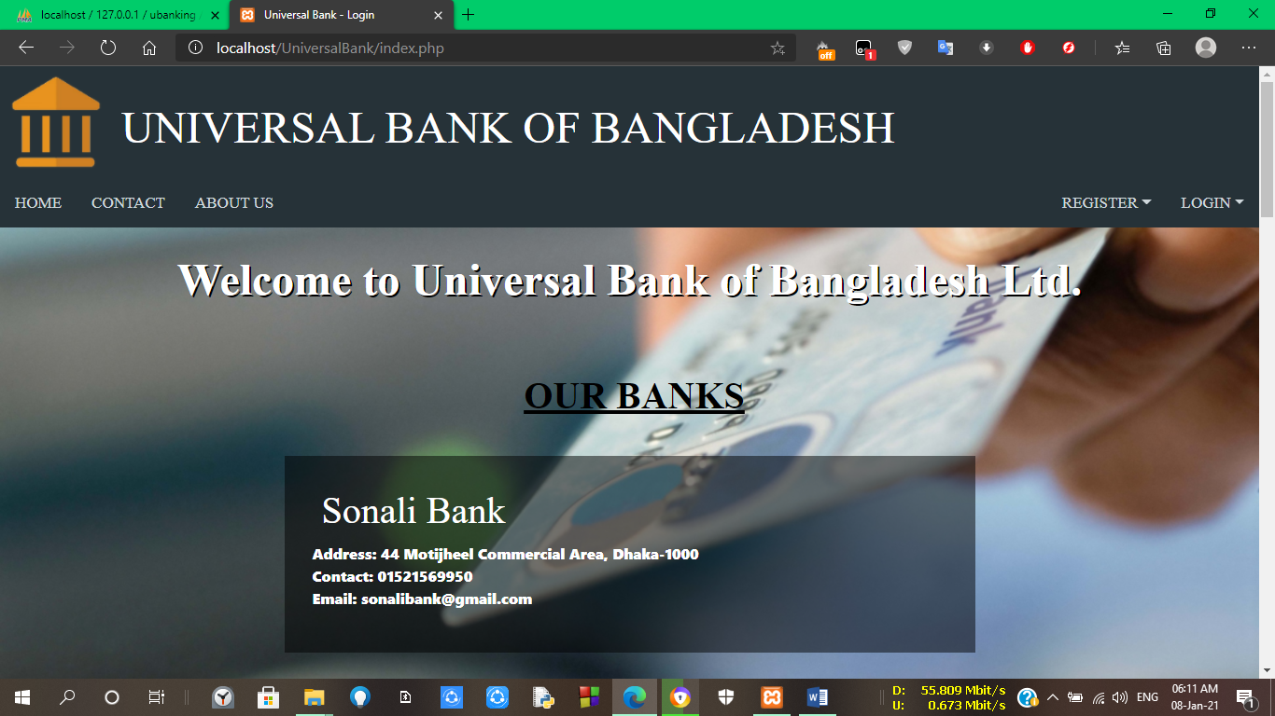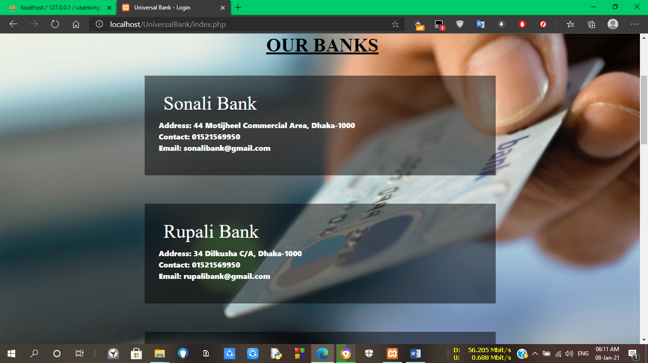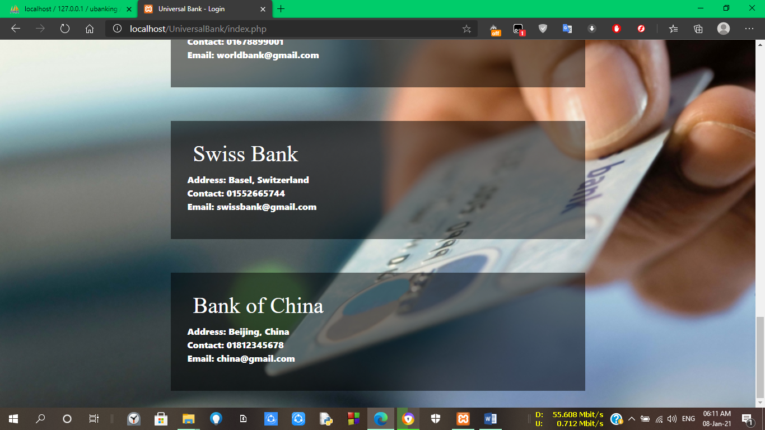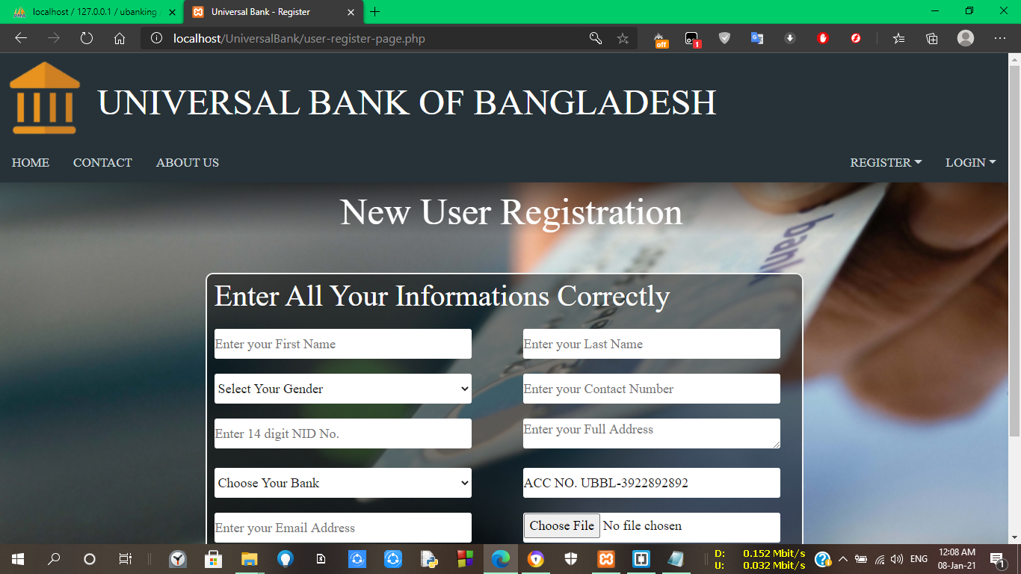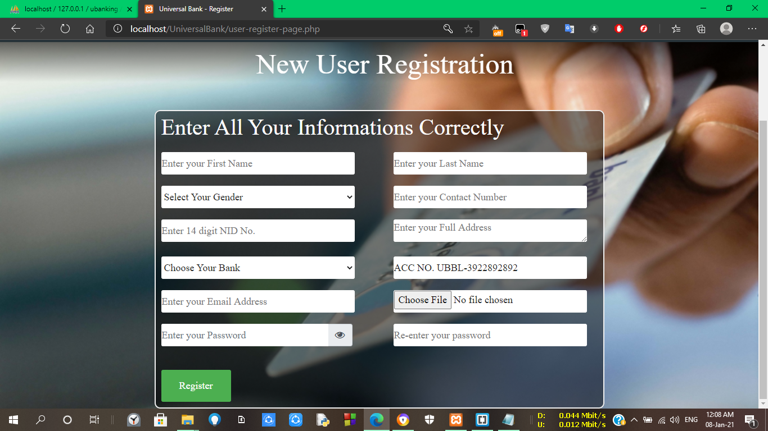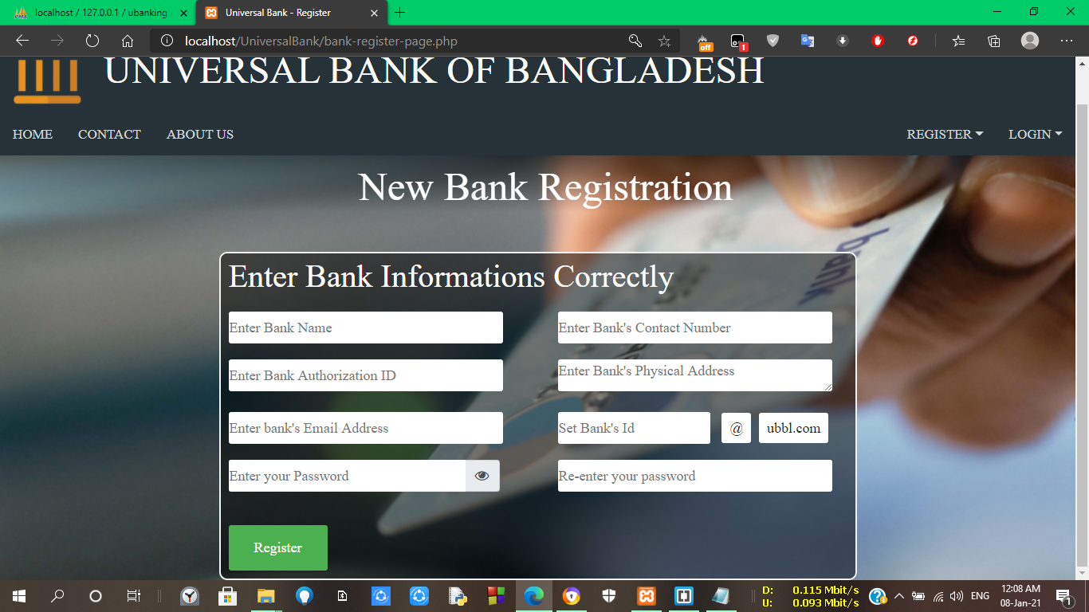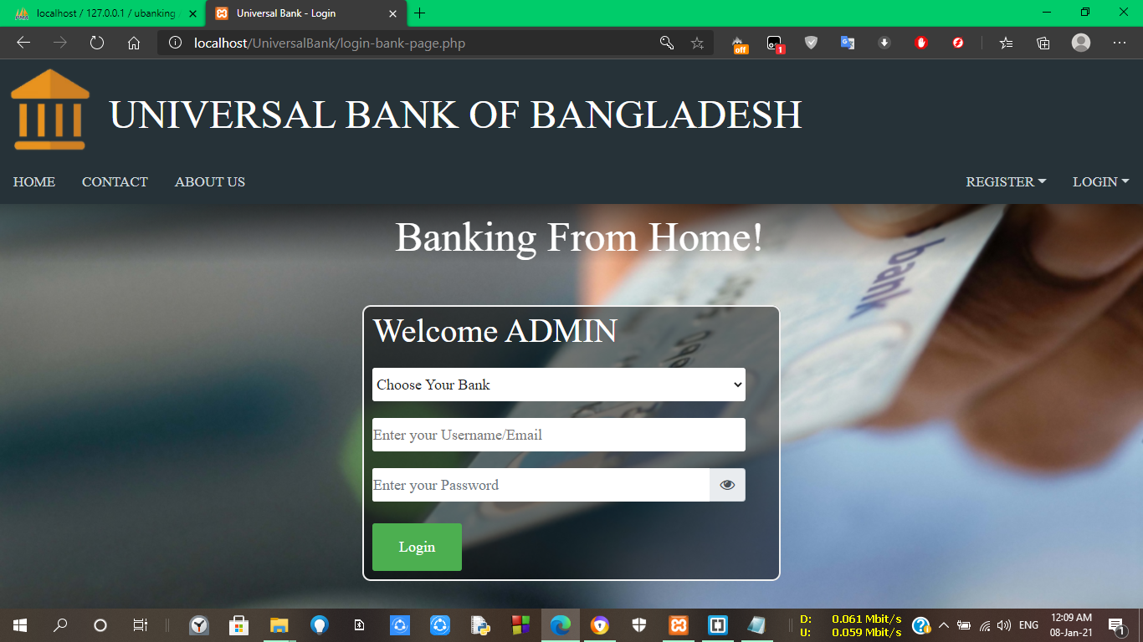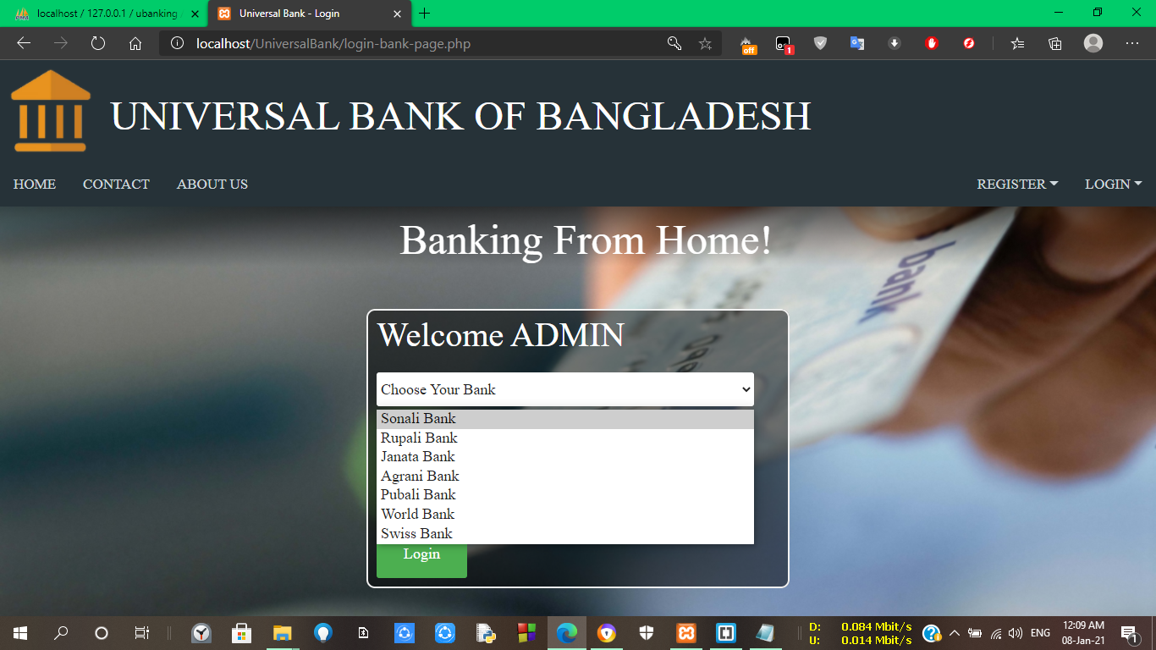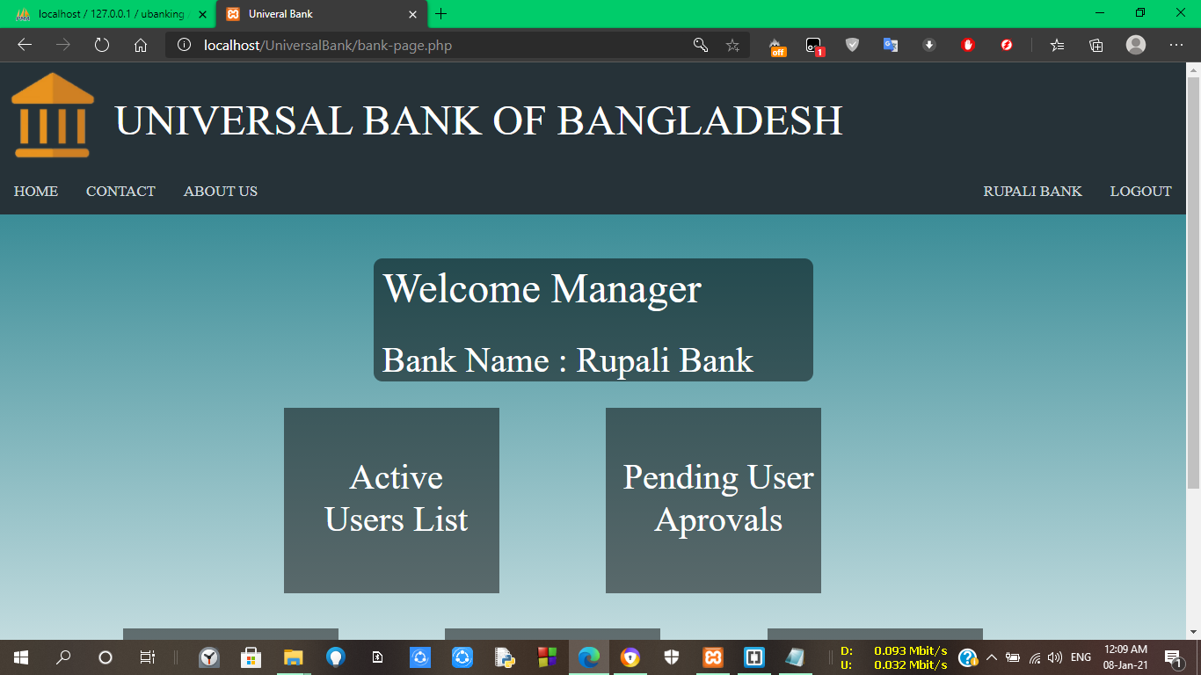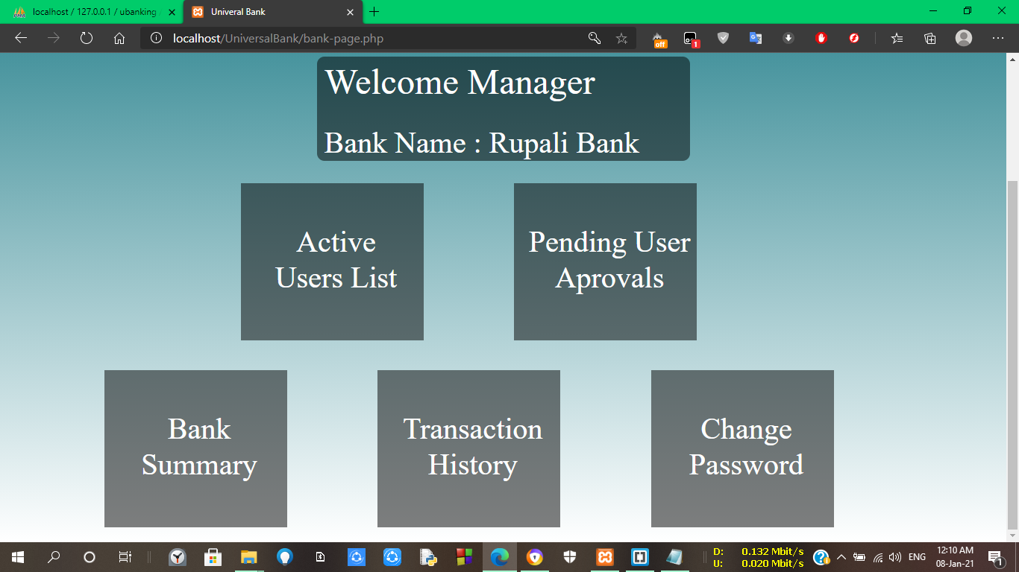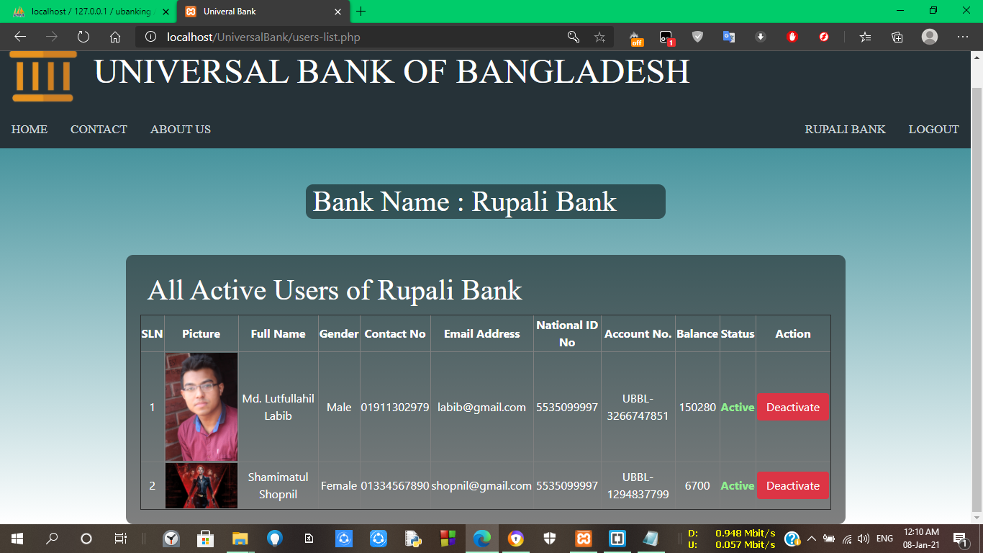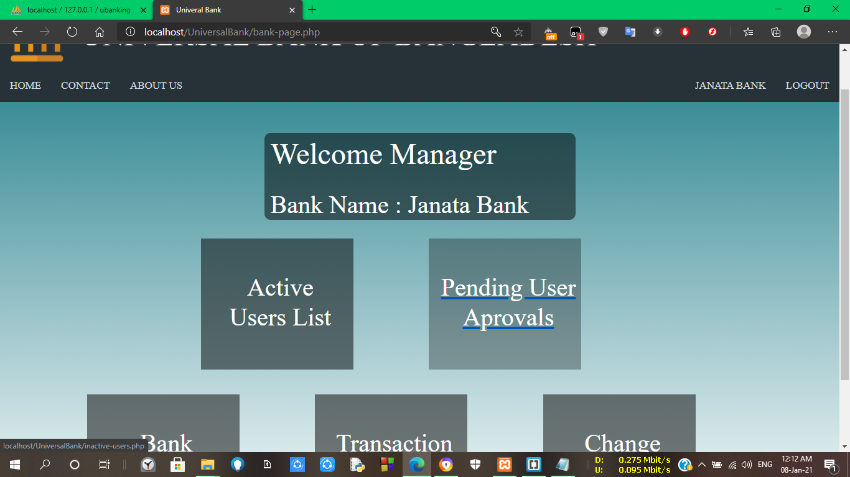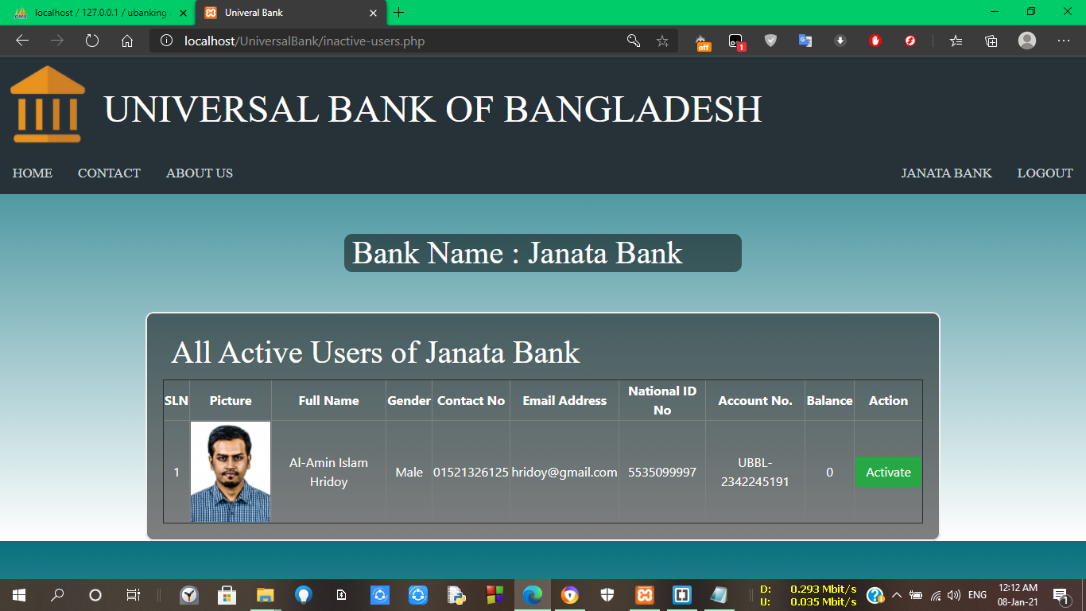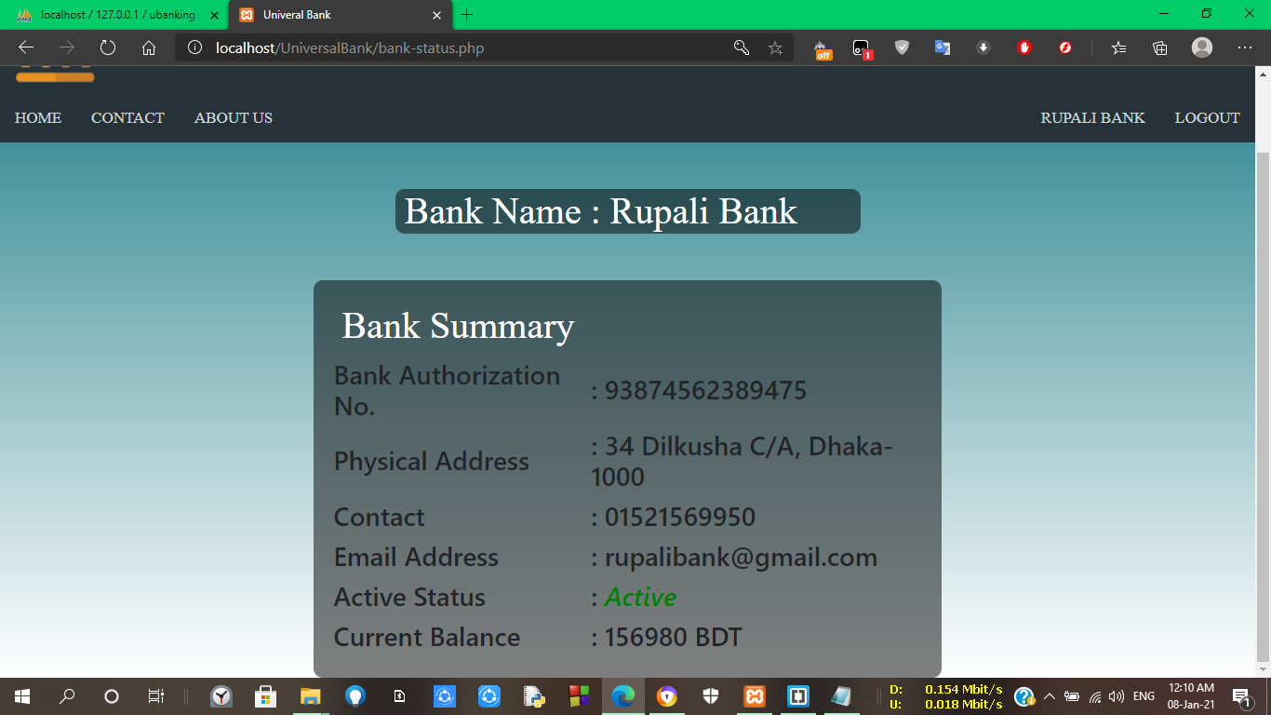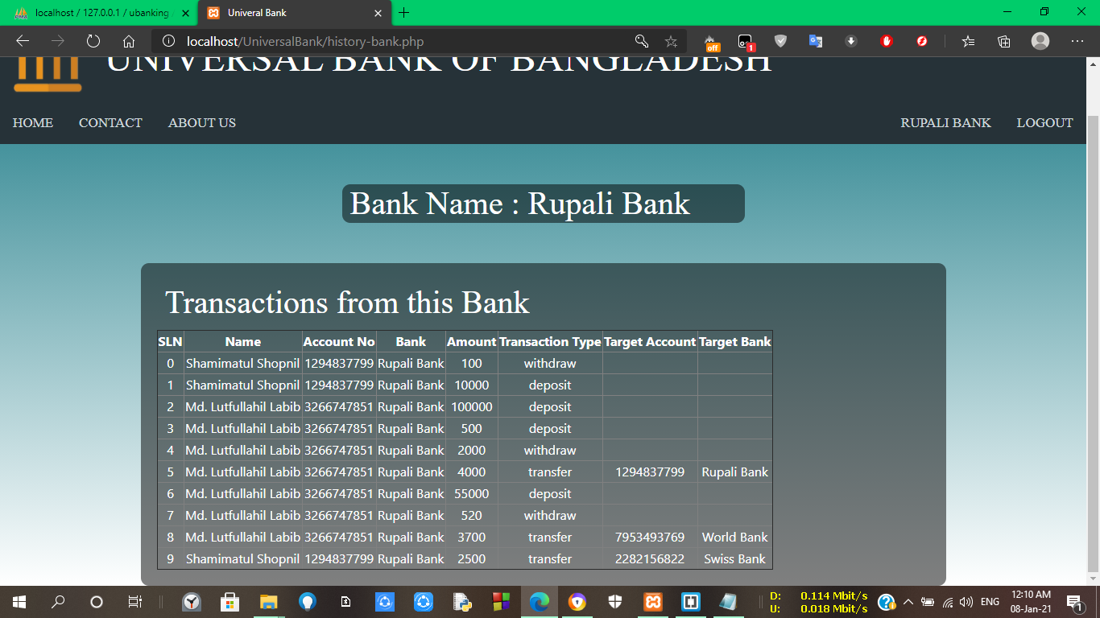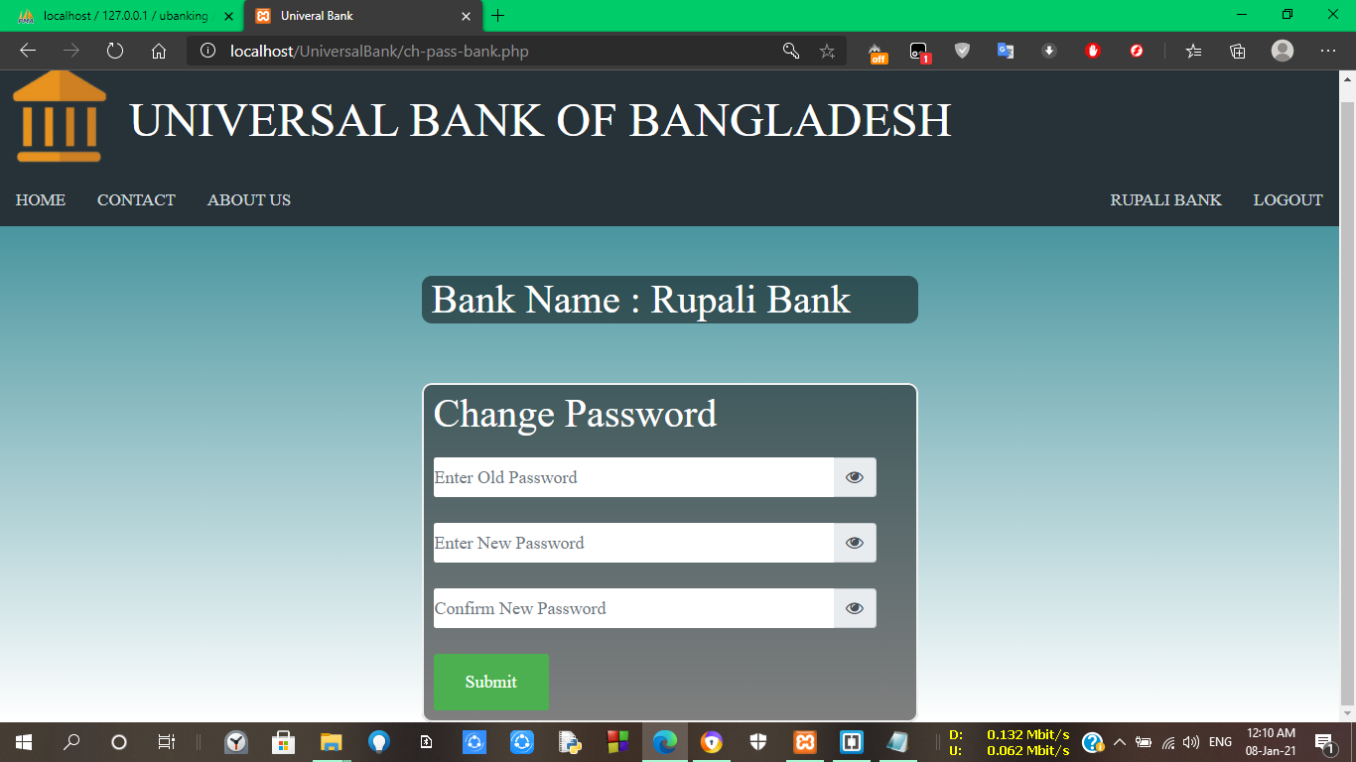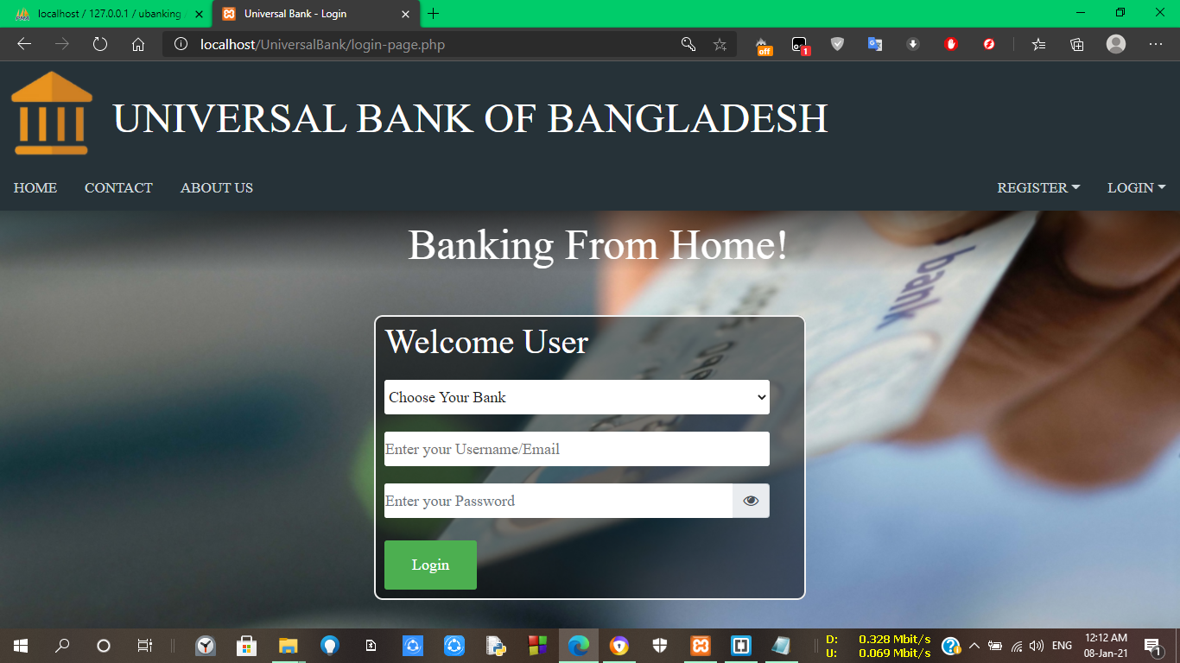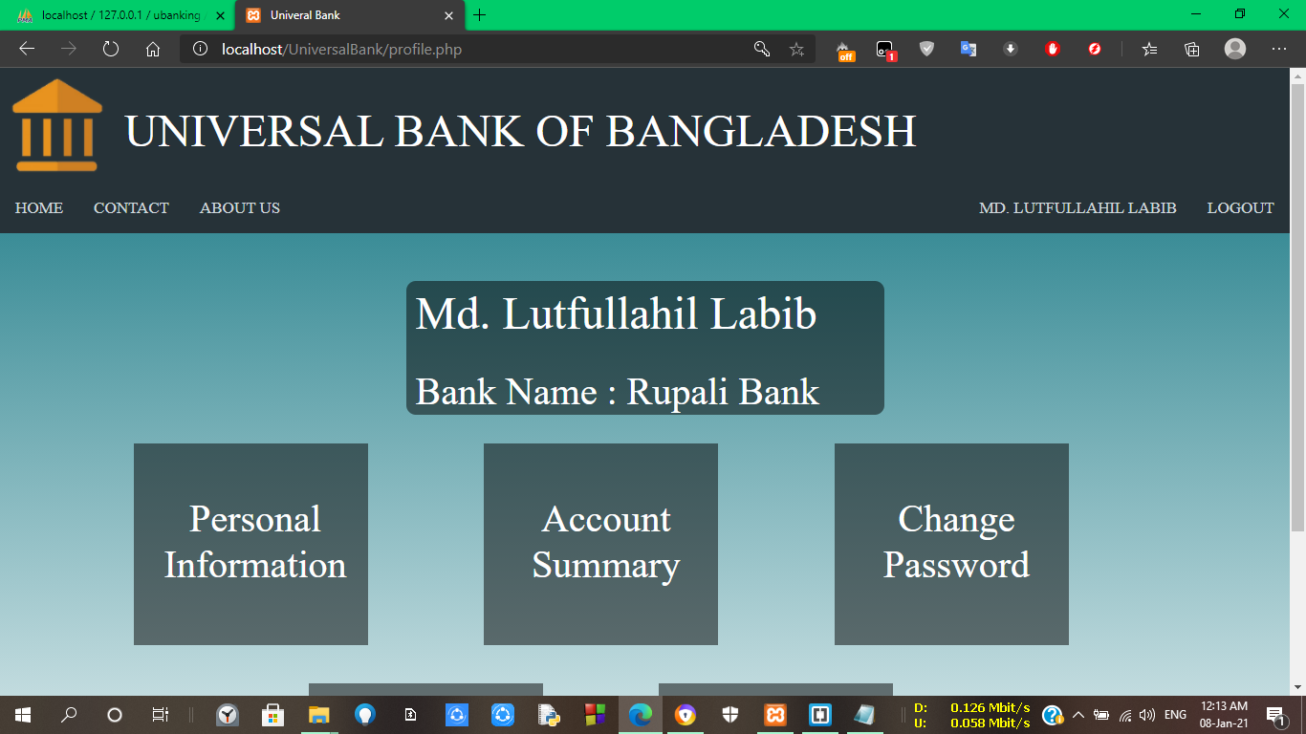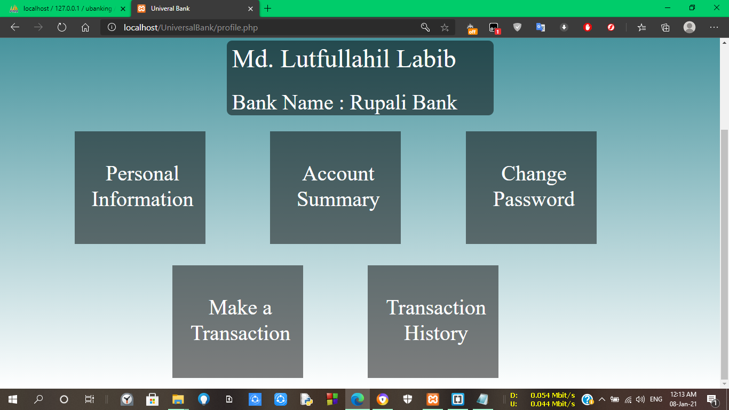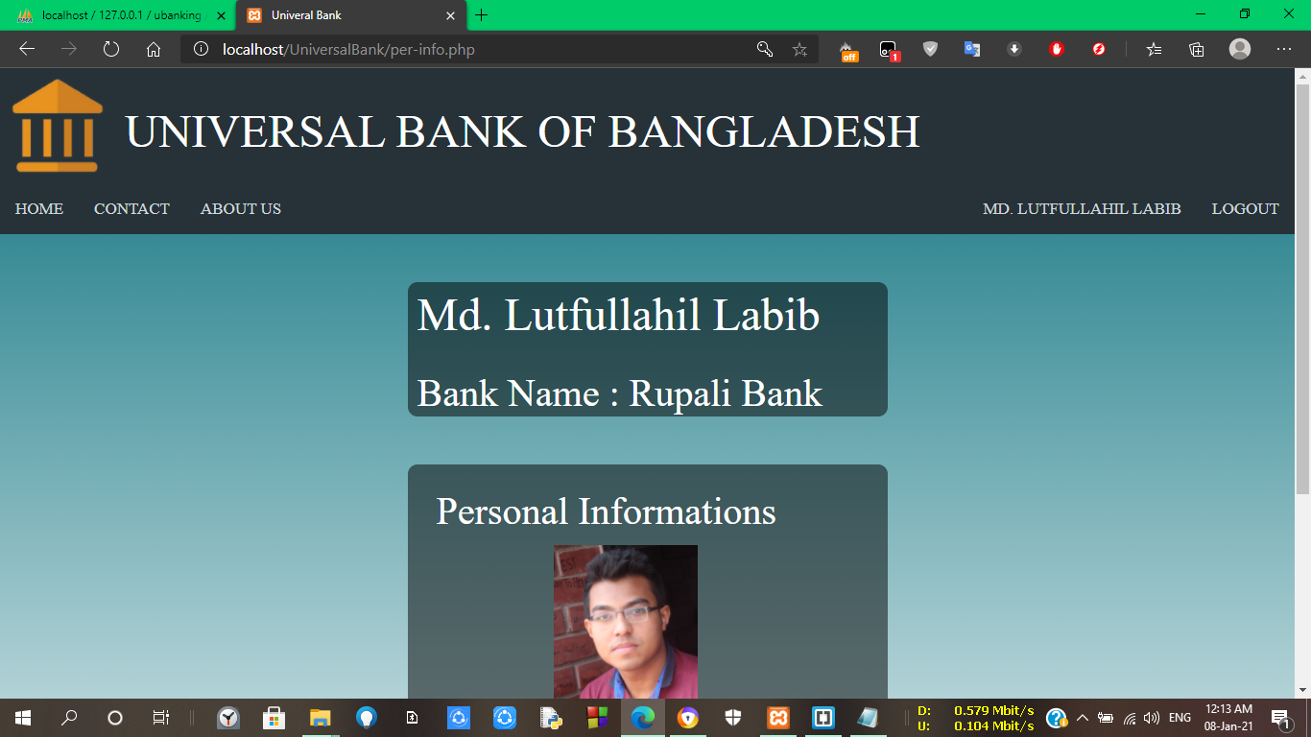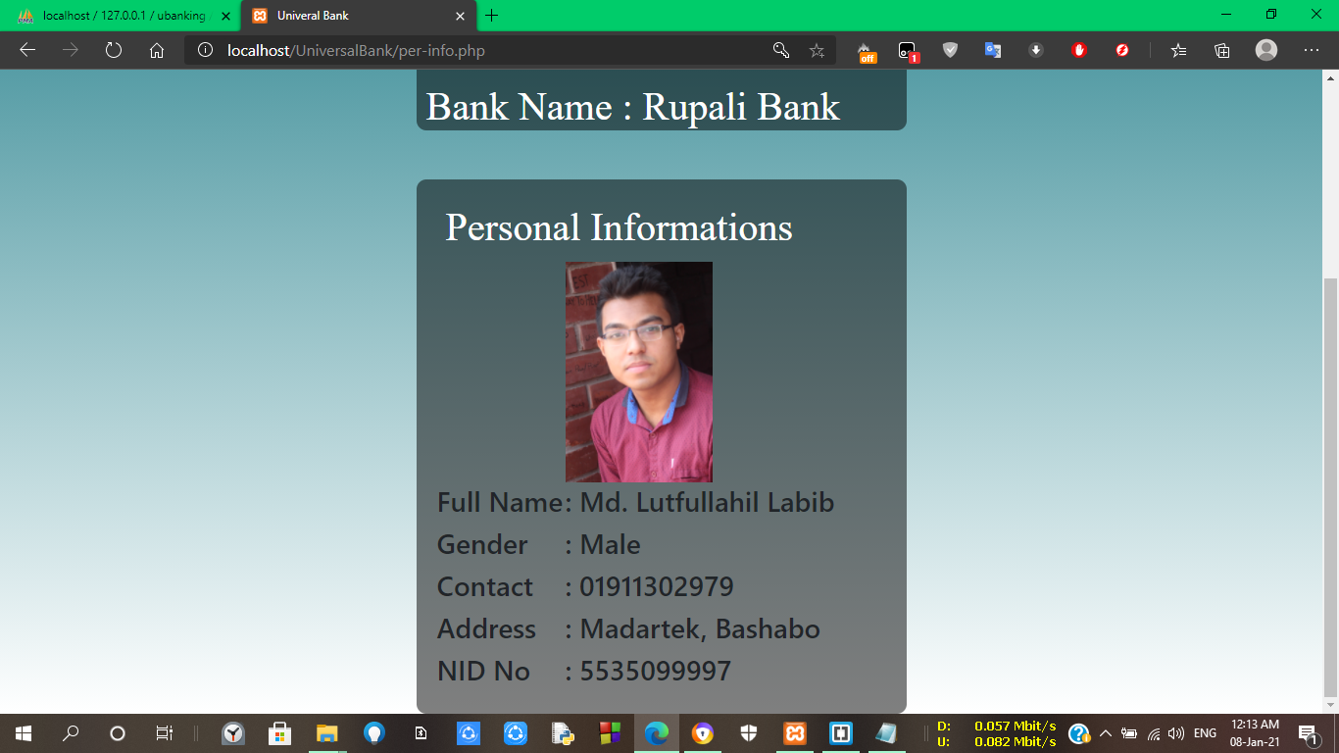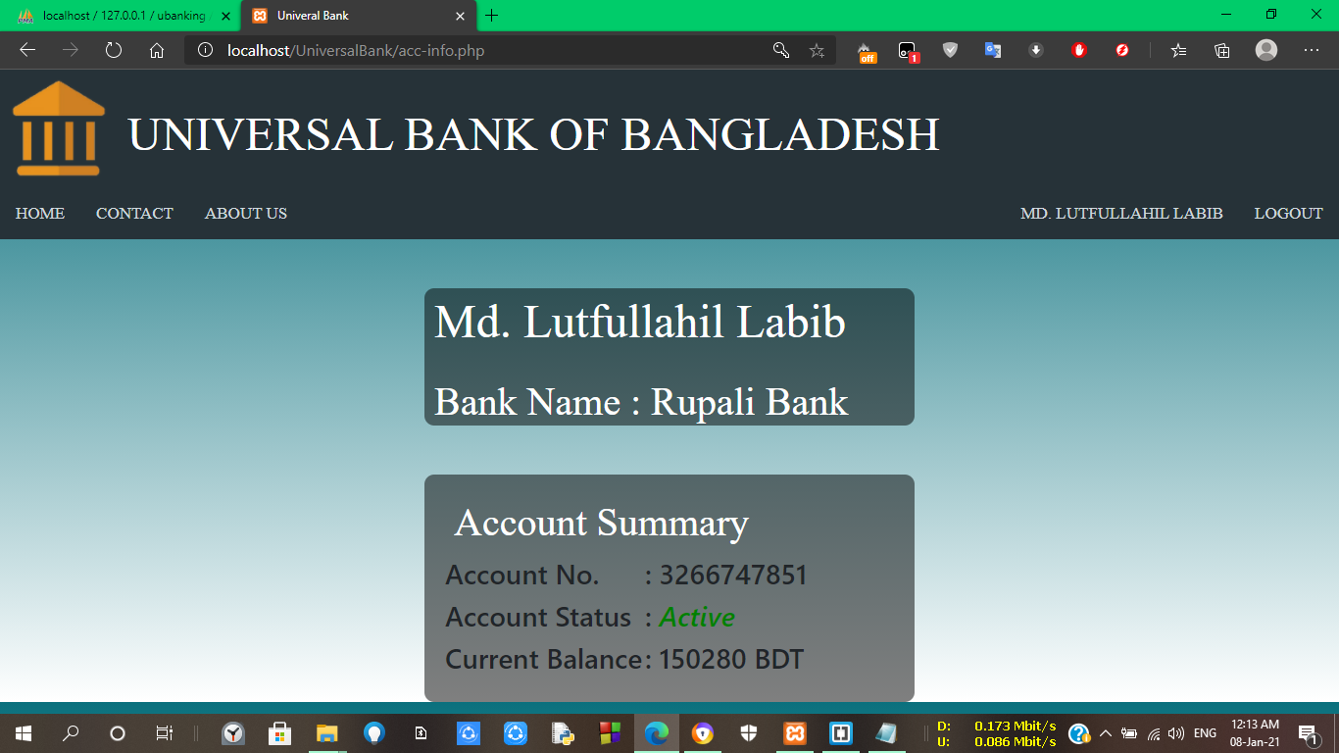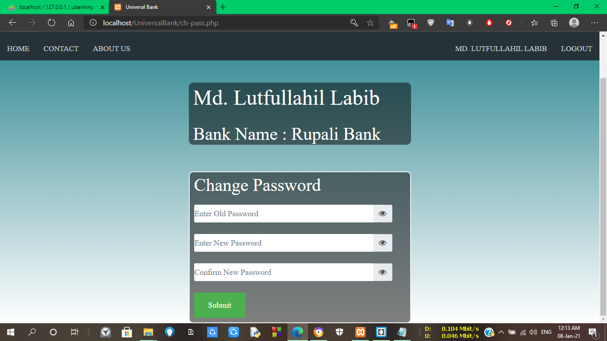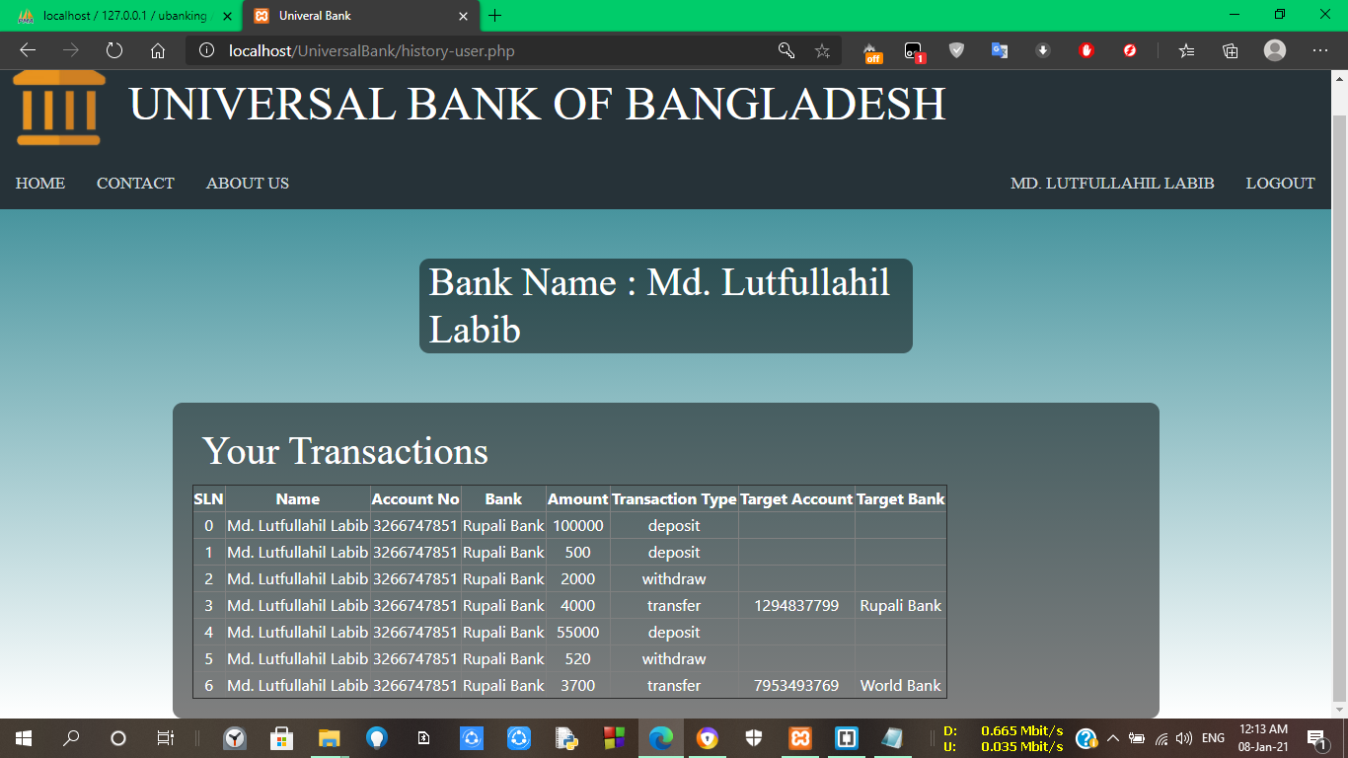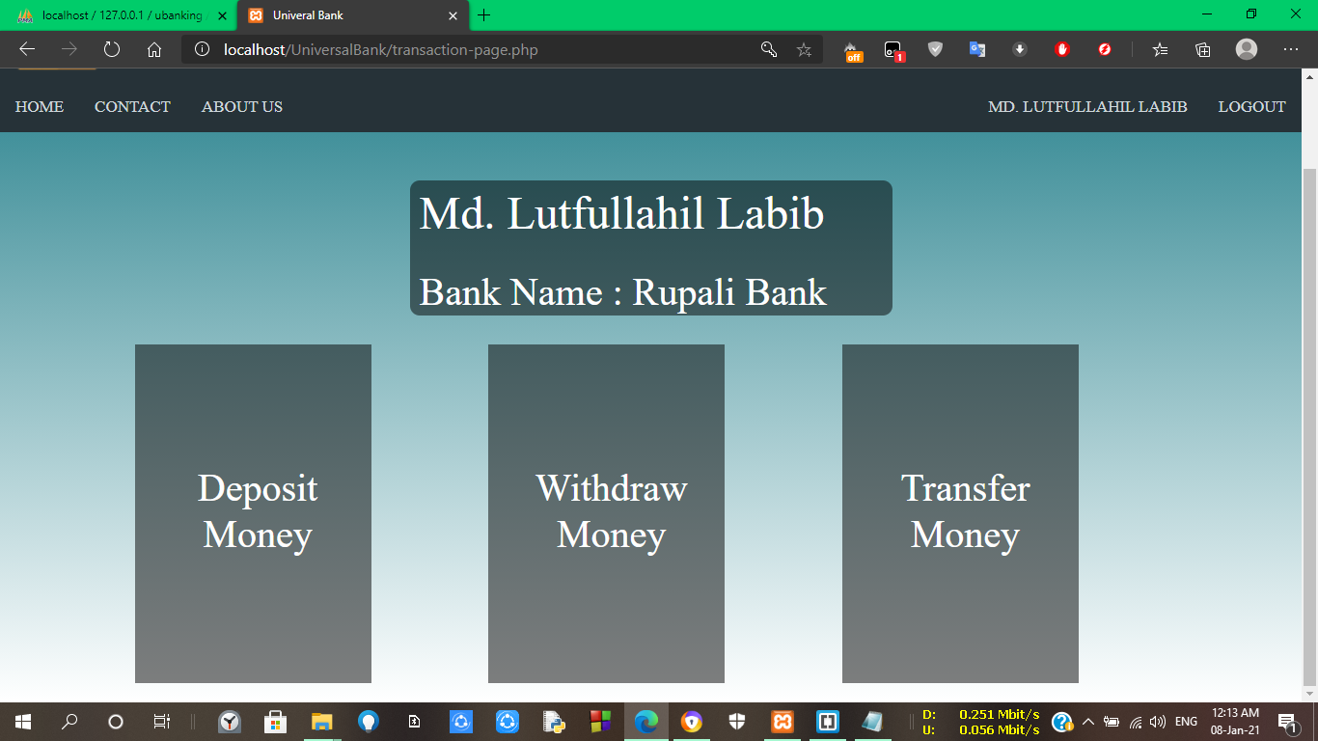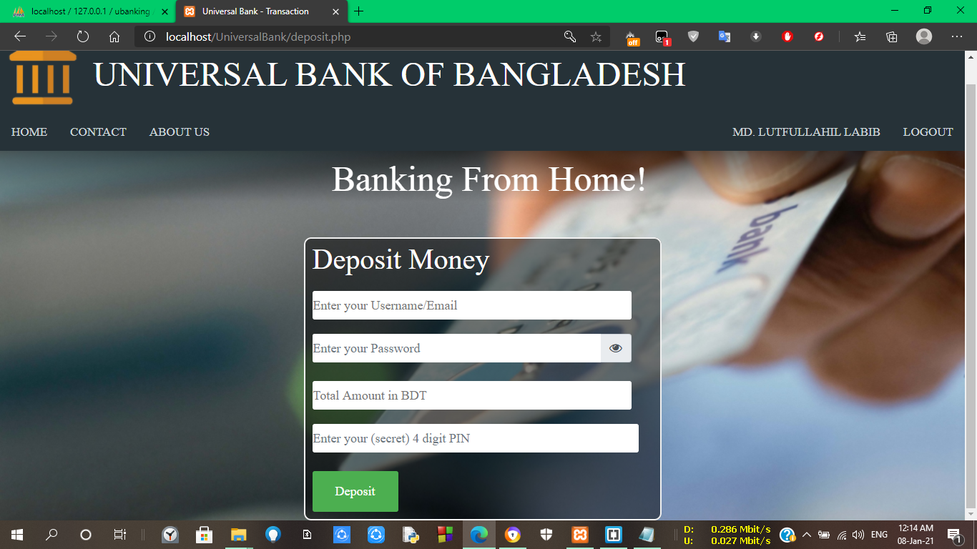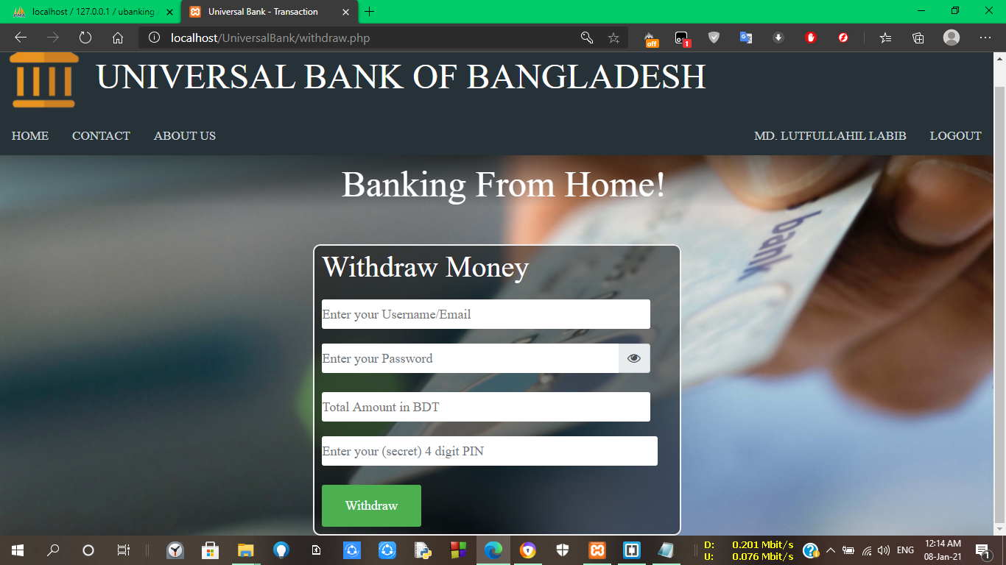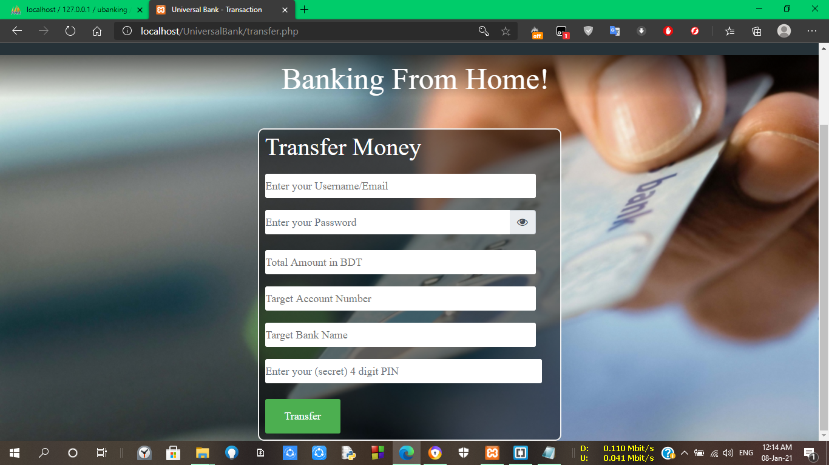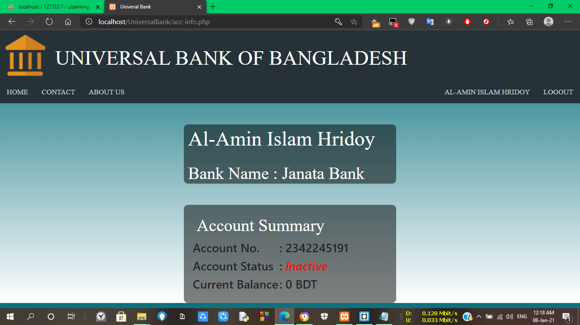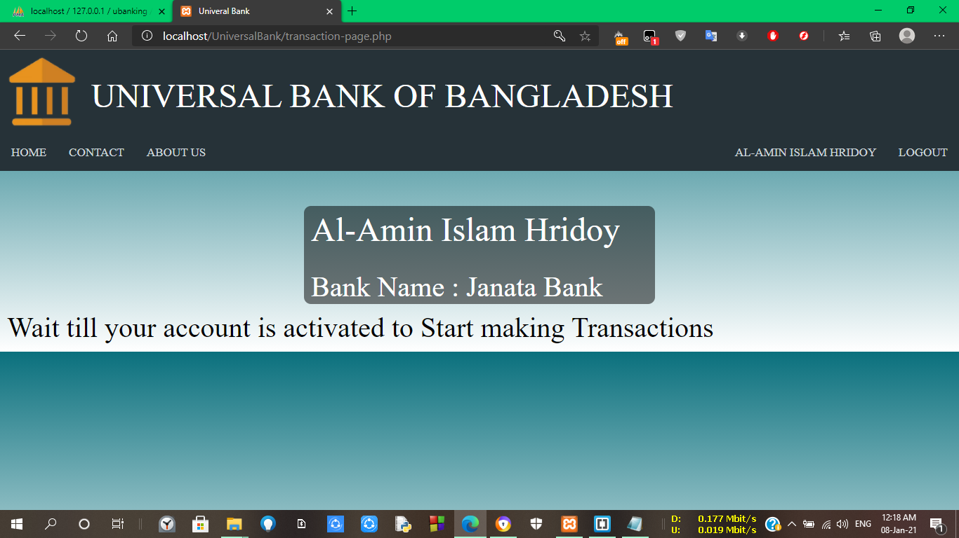

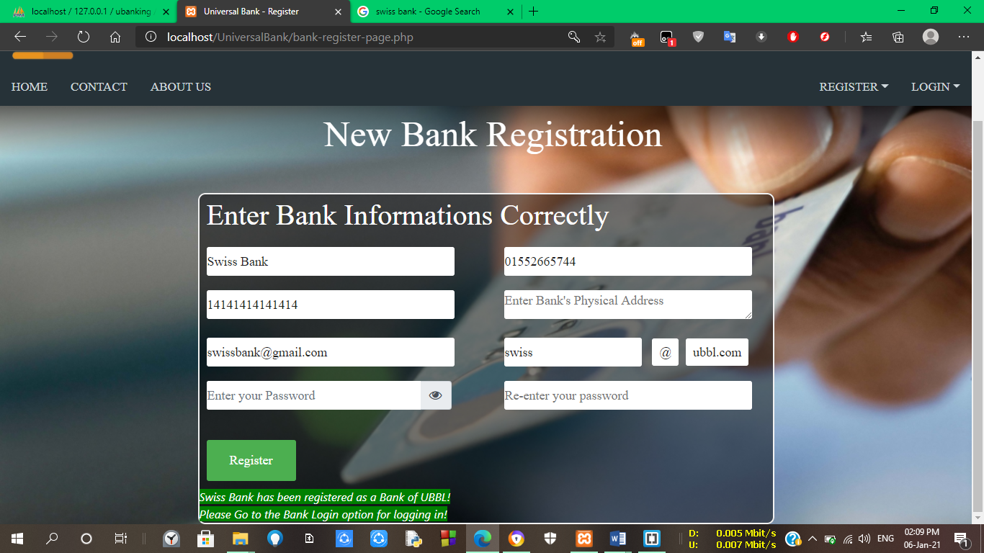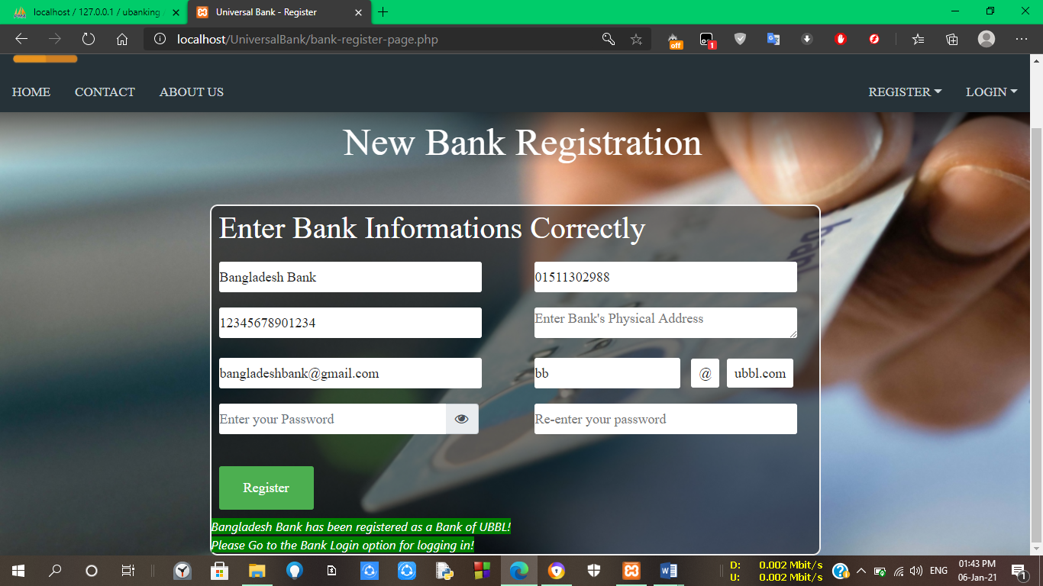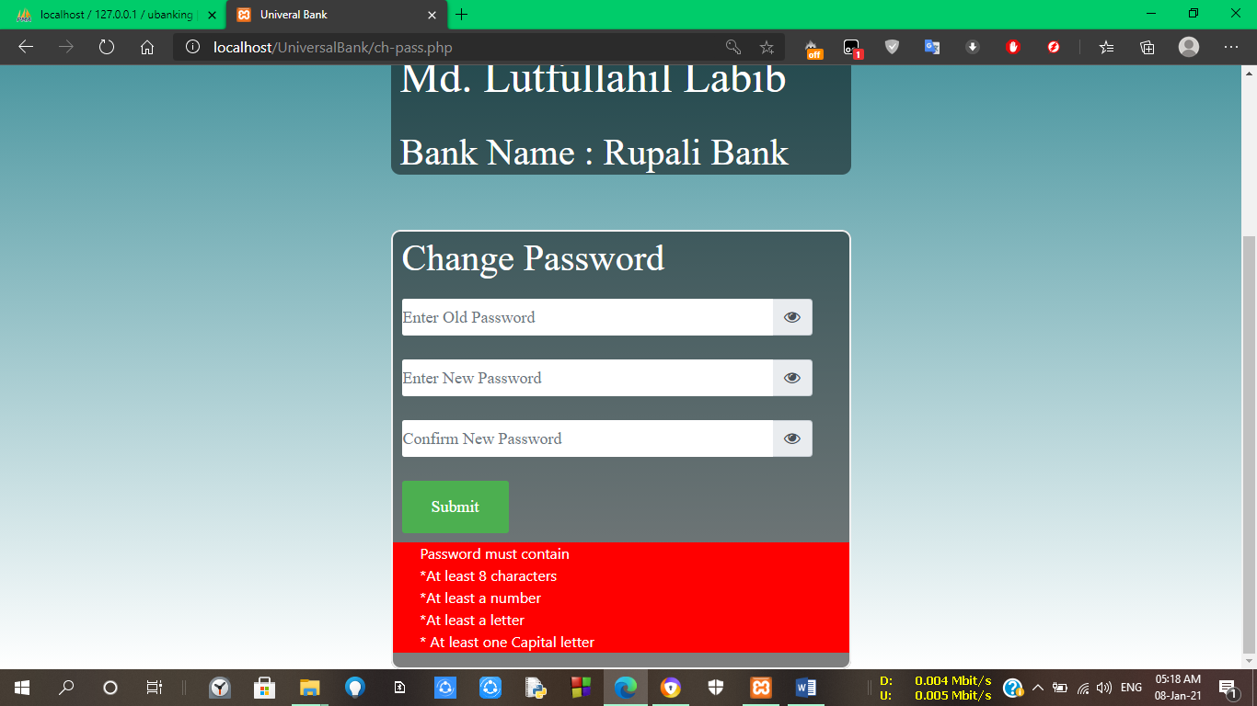

**Conclusion:** A reliable banking system is very important for our life. Often it will be tough for user for each bank they have to login in each system, which will take much time of them. Through this system banking will be easier to user, will save their time. We hope our web-app will save their time and hassle of for each bank have to login in separate system, also will be benefited for by it.